Email Subject - Are you thinking of starting a School-based Nursery?

Free Resources for School-based Nurseries

Childcare Works is the Department for Educations delivery partner, supporting Local Authorities, providers and schools to deliver the expansion of the early years entitlements and wraparound childcare programme. Find out more at: Childcare Works

Thinking about developing a School-based Nursery?
A School-based Nursery (SBN) is a form of early years childcare provision located on a school site, which supports children to get the best start in life. Take a look at the free Childcare Works resources available to schools who have, or are considering developing their SBN provision.
Key resources can be accessed via the Childcare Works HUB, a one-stop-shop connecting you with useful and reliable content, using the following links:
- A collection of informative case studies exploring how schools have embedded nursery provision on their sites: School-Based Nurseries: Five Case Studies - childcareworks.org.uk
- A series of infographics with top tips to support schools interested in establishing, expanding and sustaining early years provision: Top Tips for School-based Nurseries - childcareworks.org.uk
- A recording on delivering early years entitlements which introduces the early years expansion in schools: Delivering Early Years Entitlements in Maintained Schools and Academy Trusts - childcareworks.org.uk
- A myth-buster document for providers that addresses common misconceptions around the childcare expansion: Childcare Expansion Myth-buster for Providers - childcareworks.org.uk

DfE Capital Grant
The Government has launched phase 2 of the School-based Nurseries programme which aims to support projects to offer new childcare places in 2026/27. To support the launch of phase 2, which places an increased focus on supporting families from disadvantaged areas to access early years childcare provision, the DfE has opened applications for the Capital Grant which is designed to support state-funded primary schools with expanding or creating on-site nurseries. The deadline to apply for this grant is 5pm 11th December, and you can find out more details on the grant process here: School-based Nursery Capital Grant 2025 to 2026 - GOV.UK

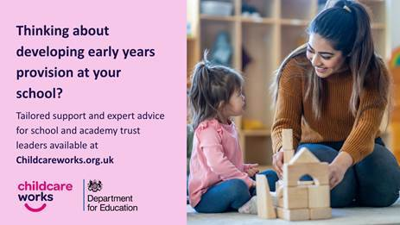

Please share this with your colleagues and wider network in the early years field who might benefit from the content.

Best regards
Childcare Works

