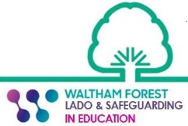
Section 11/S175 Schools and Colleges Safeguarding Audit 2023 – Staff Survey

Q1. Is the school a safe environment for:-
- Staff?

- Students?

Add comment………………………………………………………………………..

Q2. Are adequate policies and procedures in place to manage students challenging behaviour?
Yes
No
Add comment…………………………………………………………………………

Q3. Do you feel confident to recognise and respond to safeguarding concerns and to promote the welfare of students?
Yes
No

Add comment…………………………………………………………………………

Q4. Can you identify who to report safeguarding concerns to?
Yes
No
Add comment…………………………………………………………………………
Q5. Is a member of the safeguarding team always available to discuss any safeguarding concerns?
Yes
No

Add comment…………………………………………………………………………

Q6. Have you received sufficient safeguarding training relevant to your role?
Yes
No
Add comment…………………………………………………………………………

Q7. Is there any additional safeguarding training you feel would be of benefit to you/staff?

Add comment…………………………………………………………………………

Q8. Is there anything which you think would further improve safeguarding practice across the organisation?
Add comment…………………………………………………………………………

