School Census Summer 2023 Preparation Guide
PURPOSE: To assist LA maintained schools & PRU in preparing for the School Census Summer 2023.
KEY DATES
Thursday 18 May 2023 | Census Day
Tuesday 23 May 2023 | Deadline for Waltham Forest maintained schools & PRU submit a return to the Local Authority via COLLECT https://services.signin.education.gov.uk

SCHOOLS INCLUDED:
The school census collects individual school characteristics and pupil records, 3 times a year.
In England, all of the following schools are required to provide the information collected in this census to DfE:
- maintained nursery, primary, middle-deemed primary, middle-deemed secondary, secondary, all-through, special schools (including non-maintained special schools), pupil referral units / alternative provision (PRU / AP), academies (including free schools, university technical colleges (UTCs) and studio schools) and city technology colleges (CTCs).
PUPILS TO BE INCLUDED:
Individual data will be included in the return for the following pupils. You should ensure that all relevant data is maintained and up-to-date for:
- all pupils on the register on census day
- any additional pupils subject to any type of suspension or permanent exclusion in the previous 2 terms
- any additional pupils who attended the school in the previous term for which termly attendance information is required - not for nursery schools
- any additional pupils who had an alternative provision (AP) placement within the collection period (since the last census day), not applicable for nursery schools
- any additional pupils awarded a bursary since the start of the academic year - not for nursery, primary schools
- any additional pupils who were recorded as in receipt of learner funding and monitoring since the start of the academic year – not applicable to nursery schools
IMPORTANCE
The school census is the Department for Education (DfE) primary source of administrative data about pupils attending schools. The data collected support a number of the DfE’s strategic objectives and is widely used for the purpose of improving, and promoting, the education or well-being of children in England.

KEY CENSUS DATA ITEM COLLECTION PERIODS
Item | Period
Term dates | Easter Monday 2023-04-10 to 2023-07-31
Free school meal eligibility | Periods of eligibility for free school meals with:  (a) An FSM eligibility start date and no FSM eligibility end date; or,  (b) An FSM eligibility end date since the previous census, that is on or after  2023-01-20 and up to including the summer census day (2023-05-18)
Learner support (bursary funding for 16-19 year olds) | Any bursaries awarded since the beginning of the 2022 to 2023 academic year (from 2022-08-01) to students who on are either on roll or off roll on census day of 2023-05-18
Learner Funding and Monitoring (FAM) entity | Any Learner FAM assigned and hours where applicable, since the beginning of the 2022 to 2023 academic year (from 2022-08-01) to students who are either on roll or off roll on census day (2023-05-18)
Termly suspensions and permanent exclusions | 2022-08-01 to Easter Sunday 2023-04-09
Termly attendance | 2023-01-01 to Easter Sunday 2023-04-09
Alternative provision (AP) placement  module | any current (open) AP placements and  any previous placements where the pupil has already left an AP placement between: 2023-01-19 to 2023-05-17 inclusive
More DfE items info at https://www.gov.uk/guidance/complete-the-school-census/data-items-2022-to-2023

New, changeD & DELETED DATA ITEMS for Summer 2023
- NEW DATA ITEMS
None
- EXISTING DATA ITEMS
None
- DELETED DATA ITEMS
None
New, changeD & DELETED DATA ITEMS for OTHER 2022 TO 2023 SCHOOL CENSUS COLLECTIONS
More information about all changes related to other 2022 to 2023 school census collections, including this one, is at https://www.gov.uk/guidance/complete-the-school-census/changes-for-2022-to-2023.

Steps to Producing the School Census Return
The process of producing the School Census can be separated into several steps, some of which might need to be repeated to eliminate validation errors and queries.
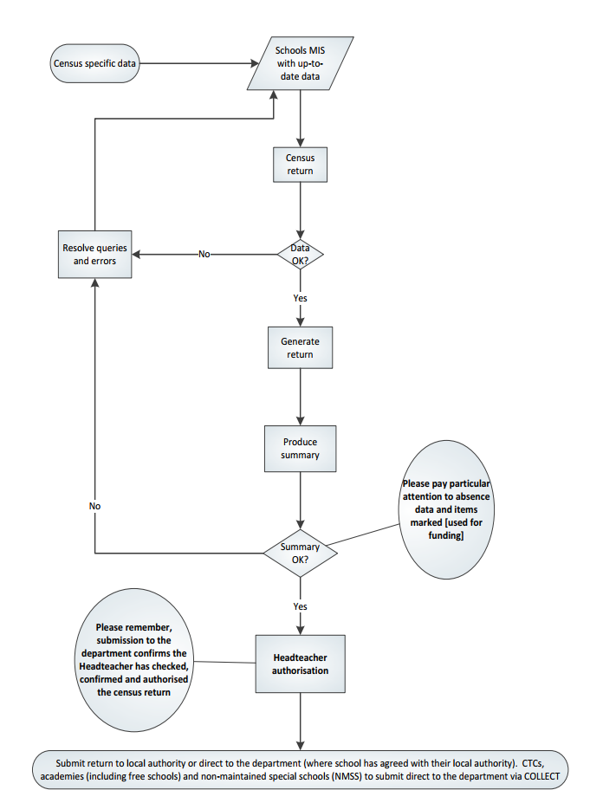

GENERATING, VALIDATING, AUTHORISING AND SUBMITTING THE RETURN
- GENERATING & VALIDATING

All relevant pupil data has been entered and updated in your management information system (MIS) before the school census return is created.
Your MIS will have validation which will help you to identify and correct errors in your data before you generate your return. Follow your MIS support provider instructions to create, validate and authorise the return.
Schools should contact their MIS support provider for specific guidance on generating and validating the return.
- AUTHORISING
Your MIS will automatically generate a summary of the data in the school census return that will:
- allow you to check that that the data is accurate and complete before sending it to the Headteacher; and
- allow the Headteacher authorising the return to check it is accurate and complete before submitting it to the local authority or DfE.
It is strongly recommended that you inspect the MIS summary report carefully, paying particular attention to the sections that might show that some individual pupil data was not entered onto the system before generating the return such as free school meal eligibility, the number of pupils with SEN, data items marked [used for funding] and absence data etc.
The Headteacher is responsible for reviewing and authorising census data before it is submitted.
- SUBMITTING
Maintained schools including pupil referral units submit data to the Local Authority using COLLECT for further validation and approval before being submitted for DfE authorisation.
The act of submitting the data automatically confirms the return as authorised by the Headteacher.
To use COLLECT to submit your school census data, you will need to log in via DfE Sign-in https://services.signin.education.gov.uk. Contact your school approver, if you want to request a DfE sign-in username or password so you can access COLLECT, or ‘school census’ is not on the list of collections you can see in COLLECT.
All school census COLLECT errors are to be corrected. All queries checked and either amended (if there is an issue); or a notepad explanation is provided in the ‘return level notes’ section of COLLECT. A DFE list of acceptable notepad entries is at www.gov.uk/guidance/complete-the-school-census/check-your-data (section ‘Adding explanatory notes for queries’).
If the DfE has any queries about your return or any of the notes added, they may also add a note to the ‘return level notes’ section of COLLECT. It is worth checking back to make sure your return is authorised.
More DfE guidance on submitting the return can be found at www.gov.uk/guidance/complete-the-school-census/submit-your-data; and checking at www.gov.uk/guidance/complete-the-school-census/check-your-data

The Local Authority will expect schools to:
- use the validation error/query reports provided by the school management information system (MIS) and COLLECT reports to resolve all errors and queries in the school management information system (MIS) and COLLECT
- use any supplementary Local Authority validation reporting provided (for maintained schools) to resolve all errors and queries in the school management information system (MIS) and COLLECT
- make a resubmission to COLLECT in all cases where there has been a change in a school’s management information system in relation to a school’s census return
- investigate all queries and either amend the data in the management information system (MIS) and resubmit a census return to COLLECT, or provide suitable notepad explanation in COLLECT for each query
- add COLLECT return-level notes where required for all queries, as per Department for Education (DfE) guidance (section ‘Adding explanation notes for queries’)
- resolve all COLLECT duplicates, as per Department for Education (DfE) guidance (sections ‘Duplicate report: same UPN’ & ‘Duplicate report: same person different UPN’)
- access and use all relevant COLLECT pupil number and funding reports, as per Department for Education (DfE) guidance (section ‘COLLECT reports used for funding’ and other sections related to COLLECT reports) to support the submission of an accurate statutory return.
‘Dry Run’ & Testing: Schools should take the opportunity to do a ‘dry run’ of their school census return. The purpose of a dry run is to provide details about any corrections that need to be made to your data to make it acceptable for inclusion. So that you are aware of any potential issues, it is advisable to do this as early as possible, even if you know that your data has not yet been fully prepared or checked. Contact your management information system (MIS) Support Provider for any procedural guidance to facilitate a dry run.
COLLECT Familiarisation: A ‘beta’ release of the School Census live COLLECT blade will be available to schools. This will remain available prior to the start of the live collection. COLLECT familiarisation will take place on the same system as the live collection and, therefore, can be accessed by logging into COLLECT.
The DfE would strongly recommend that, if possible, all schools take the chance to load a file output from their management information system (MIS) into COLLECT during the familiarisation process. This will allow schools to check that all the required data is being output correctly from their MIS into the Spring census return and whether any validation errors or queries are generated against their data when loaded into COLLECT which need to be resolved before the collection goes live.
WHO TO CONTACT?

Contact | Support
Families Business Intelligence Team  E-mail: edu.performance@walthamforest.gov.uk | School Census data collection and return queries.
Department for Education (DfE)  https://form.education.gov.uk/service/Data-collections-service-request-form | DfE Data collections service request form.

SUMMER 2023 SCHOOL CENSUS – CHECKLIST
This checklist indicates some of the tasks to undertake to prepare for the school census. Your MIS Support Provider may provide a more specific procedural list of tasks that you should follow. More information about school census data items is at https://www.gov.uk/guidance/complete-the-school-census/data-items-2022-to-2023.
MIS Permissions: Check with your System Administrator/Manager that you have the appropriate permissions to run the School Census and record associated data.
MIS is the correct version? Upgrade to the correct MIS version to run School Census.
Dry Run: Carry out a dry run to determine what information needs to be updated.
School information: Check school level information e.g. establishment details & school email.
Alternative provision (AP) placements:
- Alternative provision for single-registered pupils (those with an enrolment status of ‘C’, ‘F’ or ‘O’) - completed by PRU or AP schools. Data should be submitted for pupils both on and off roll who have been placed in AP within the census period. Includes:
- single-registered pupils on roll on census day;
- pupils who were single registered but who have been removed from the roll within the census period
If a pupil has been single registered in your school on more than one occasion within the census period, return the information for the most recent placement only.
If your school has arranged placements in other AP settings for these pupils, you should also complete the alternative provision placements arranged by schools module for each placement
- Alternative provision placements arranged by schools - completed by any school that has arranged a placement, including primary schools, secondary schools, all-through schools, special schools and PRU or AP schools.
Data should be submitted for pupils both on and off roll who have attended AP placements within the census period. This includes:
- AP placements that are taking place on census day
- previous placements, where pupil has left the AP placement within the census period
Where pupils have attended more than one AP placement within the census period, including multiple placements with the same AP provider, you should record and submit information on each placement separately.
More information at https://www.gov.uk/guidance/complete-the-school-census/data-items-2022-to-2023
Attendance: Check attendance data.
Adopted from care: Check adopted from care information.
Enrolment Status – dual registrations: All pupils on roll at your school and another school/PRU must have the correct enrolment status recorded (i.e. M = Dual Main or S = Dual Subsidiary).
FSM: Check free school meal eligibility information.
Note: All pupils in Reception, Year 1 and Year 2 are offered a meal regardless of whether they are eligible for free school meals. Pupils in Reception, Year 1 and Year 2 must only be recorded as eligible for a free school meal if they meet the criteria for free school meals.
Transitional protections ensure that any pupil in receipt of free school meals on 31 March 2018 or after, should continue to receive free school meals until the end of the universal credit roll out period, and then until their phase of education ends. This covers until at least March 2025 and applies even if their circumstances change, and they would no longer meet the eligibility criteria.
You should not enter end dates unless:
- a parent has said that they do not wish the child to be recorded as eligible for free school meals and receive a free school meal
- a pupil transfers from another UK country – their non-English free school meals must have an end date
- a parent notifies the school that their support under the Immigration & Asylum Act 1999 or the pension credit has ended
- a parent notifies the school that they no longer qualify for free school meals under the criteria for families with no recourse to public funds (NRPF)
Full-time/part-time status for pupils who are not of statutory school age: Please ensure that each pupil in these year groups is correctly shown as full-time or part-time.
Funded hours for pupils aged 2, 3 or 4: Check the funded entitlement hours information.
Hours at setting for pupils aged 2, 3 or 4: Check that it is the total of:
- any hours funded under the free early education entitlements, plus
- any hours funded under extended funded entitlement, plus
- any additional hours of education funded from other sources such as parents.
First Language: Check first language information Collected for all pupils including nursery schools.
Learner Funding and Monitoring (FAM): All schools (except nursery) update Funding and Monitoring details as required by the DfE. For the 2022 to 2023 academic year, it will identify pupils:
- in receipt of tutoring funded by the National Tutoring Programme funding (this tutoring could be delivered via school-led tutoring, an academic mentor or a tuition partner). The DfE will collect data on which pupils are receiving tutoring and also the cumulative number of hours (to the nearest 0.5 hours) the pupil has received since the start of the 2022 to 2023 academic year, up to and including census day.
The DfE advises that tutoring courses for each pupil should be 12 to 15 hours to have a meaningful impact on pupil attainment, however you should enter the actual number of hours provided to each pupil whether this is more or less than the recommended hours. If a tuition session is cancelled (a pupil did not receive tutoring) it should not be recorded in the census.
- in receipt of tutoring funded by the 16 to 19 tuition fund.
- resitting or retaking full or part of their 16 to 19 study programme.
Leavers: Check that leavers and re-admissions have been recorded.
Post Looked After pupils: Check information collected for pupils who are on-roll on census day. Post looked after arrangements collects information regarding children, who have left local authority care in England and Wales through adoption, a special guardianship order, a residence order or a child arrangements order and are subject to such orders on census day.
Children who have left care under one of the measures listed above will be eligible for the post looked after element of the pupil premium.
From autumn 2022, the DfE have extended these options to include code ‘O’ - children adopted from state care outside of England and Wales.
Pupil SEN provision: Check special educational needs information. SEN provision is collected for all pupils on roll on census day.
Termly suspensions and permanent exclusions: Check information.
Top-Up Funding Indicator: Check this information for those pupils on roll for whom the school receives, on census day, high needs top-up funding either from a local authority or, in the case of a PRU / AP, a local authority or another school.
Usually, but not always, the pupils for whom a primary or secondary mainstream school receives top-up funding are those with an education, health and care plan (EHCP). More information is at https://www.gov.uk/guidance/complete-the-school-census/data-items-2022-to-2023 (‘Top-up funding indicator’ section).
Unique Learner Numbers (ULN): Pupils aged 14 and above on census day must have a ULN.
Unique Pupil Numbers (UPN): If you have pupils with a temporary UPN or new pupils that require a UPN, check whether they already have a permanent UPN assigned to them.
Universal Infant Free School Meal taken on census day: For each pupil in R, 1 & 2 the census records if the pupil had school lunch on census day. The DfE use this for Universal Infant Free School Meal (UIFSM) funding.
Youth Support Services Agreement (YSSA) [Not for Nursery schools and primary]:
Check the Youth Support Services Agreement (YSSA) status is correct. The youth support services agreement indicator applies to:
• SEN pupils aged between 12 and 25 with date of birth between 1996-09-01 and 2010-08-31
• all other pupils aged between 12 and 20 with date of birth between 2001-09-01 and 2010-08-31.
There is a legal requirement under the Education and Skills Act 2008 for schools to pass information on request to the youth support service for pupils in or approaching the age of 13.

