Autism Friendly Competition Guidance
- Please create a design of what autism friendly means to you.

- Your design should fit on the next page.
- Things to avoid using:
Puzzle Pieces the puzzle piece also represents viewing autistic people as ‘puzzling’ or a ‘mystery’. For autistic people this is problematic, as they do not wish to be viewed as a puzzle that can’t be worked out.
Blue was previously used as it was believed that autism was linked to boys only, however this is incorrect and there are many autistic females too.
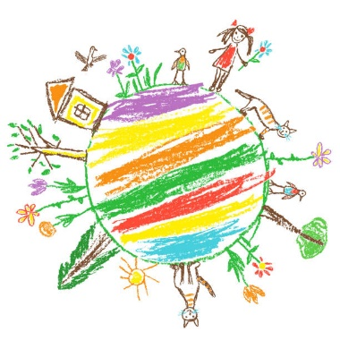
- Things that are good to use:
Gold the element symbol for gold is AU which is also the first two letters of autism and is seen to be a positive colour.
Colours of the rainbow as this represents neurodiversity, rainbows and neurodiversity are both made up of spectrums.
Infinity symbol to represent inclusion - everyone on the autistic spectrum is included, no matter what their unique form of Autism looks like.
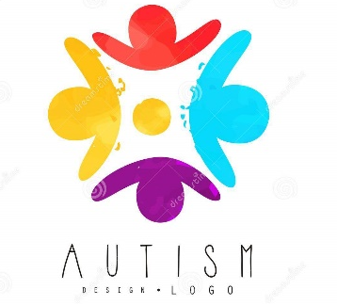
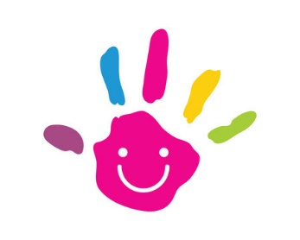
- Here are some examples of good logos:

- Keep it simple, fine details such as people and faces may be lost in final design print.
- If you would like to enter a suggestion for the name of our autism campaign alongside your design please add it here:

