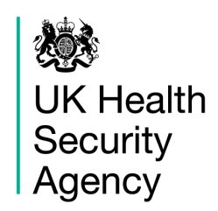
Hot Weather Communications Toolkit

2022
1. Introduction

The Heatwave Plan for England was developed to raise public and professional awareness of the health impacts of hot weather. The plan is an important component of overall emergency planning and provides advice for professionals, organisations, communities and individuals to enable them to plan for and respond to hot weather. The Heatwave Plan for England remains largely unchanged for summer 2022.

The plan recommends a series of steps to reduce the risks to health from prolonged exposure to heat for:

- the NHS, local authorities, social care, and other public agencies
- professionals working with people at risk
- individuals, communities and the voluntary sector

This toolkit provides pre-prepared material to share with your social media teams, as well as statements that can be used according to the alert level in place at the time.

Many people enjoy hot weather but there can be serious health consequences from too much exposure to heat and vulnerable groups are at risk in particularly hot spells. However, there are reputational risks from broadcasting advice seen as too precautionary when many may just want to enjoy some sunshine. It is not an easy message to get across, but it is important due to the significant impacts on health that occur during hot spells.

This toolkit intends to provide the basic health messages that can be communicated during hot spells so that the right messages reach the right people at the right time.

Content included here can be used to target both public and professional audiences.

UKHSA uses the term ‘Heat-Health Alert’, instead of heatwave alert as heatwave is a meteorological definition, which is not the same as the thresholds used for the alerting system. If media choose to use ‘heatwave’ we won’t object but we will stop using it, so that our communications language takes account of the specific public health considerations around heat and are aligned with terminology used by the Met Office. The plan itself will retain the name Heatwave Plan for England until further notice.

2. Heat-health alerts

The Heatwave Plan for England is supported by the heat-health alert system, which operates annually from 1 June to 15 September.

This is a UKHSA commissioned service, although the alerts are often referred to as the Met Office health heat alerts. During this period, the Met Office, with agreement from the UKHSA Extreme Events and Health Protection team, may issue an alert, should the forecast indicate the need to do so. Levels are defined by forecasts of day and night temperatures and their duration. Decisions to issue an alert also take into account a dynamic assessment of other contextual risks. The decision to issue a level 4 alert is taken at a national level with cross-government involvement. For precise definitions of regional criteria see page 43 of the Heatwave Plan for England.

The heat-health alert system comprises five levels – four levels of response in addition to level zero which relates to long-term, year-round planning. Temperature thresholds vary by region, but an average threshold temperature is 30°C by day and 15°C overnight for at least two consecutive days.

- Level One: (L1) This is the minimum alert level and is in place every year from June 1 until September 15, which is the period that heat-health alerts are most likely to be issued. This minimum alert simply means that people should be aware of what to do if the alert level is raised. Extraordinary alerts can be issued outside of this time.
- Level Two: (L2) Issued when the regional threshold temperature will be exceeded within the next few days.
- Level Three: (L3) Issued when the threshold temperature has been exceeded.
- Level Four: (L4) Issued when there is a severe hot spell with impacts across other sectors and infrastructure in addition to health.

3. National Severe Weather Warning Service
Met Office Extreme Heat Warnings
The Met Office will have the capability to issue Extreme Heat Warnings (EHWs) as part of the UK’s National Severe Weather Warning Service (NSWWS). This capability must be UK-wide, include the impacts of severe weather outside of the health sector (e.g. transport) and should complement and enhance existing heat services across the UK, including the UKHSA heat health alerts.

As with other NSWWS warnings, the final decision to issue an EHW resides with the Met Office Chief Operational Meteorologists, but this decision will be based on a dynamic risk assessment. A Level 3 alert alone may not be sufficient for the issue of an EHW, but it is likely that EHW will be issued in the situations in which further escalation within Level 3 (and to Level 4) is necessary. Thus, there will be no yellow EHWs, with amber and red being considered if a prolonged or severe heatwave is possible. EHWs will match the equivalent heat health alert colour. In terms of the NSWWS impact matrix (see diagram), only the top right four boxes – representing likely medium and high impact events – will be used. EHWs will also broadly match the areas and timings covered by the Level 3/4 heat health alerts.

Warning impact Matrix

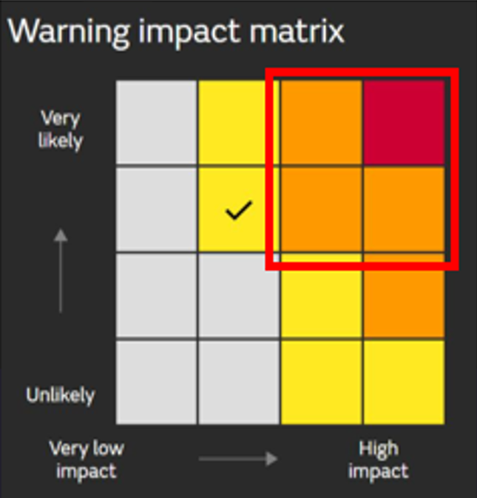
4. Public communication in hot weather

The heat-health alert system was designed to be for professionals rather than public facing and thus the alert levels are not typically used in public facing communications. However, some media continue to use the alert levels to explain the severity of an event and may continue to do so.

It is important to note that the health impacts of hot weather start to occur at levels below the alert thresholds; the alert levels are set to indicate impacts on health which are at a magnitude where the system (health and social care in particular) need to take action to prevent harm. As such it can be useful to provide general heat health advice even when alert thresholds are less likely to be met. UKHSA may issue advice when temperatures are high (approximately 25°C or higher) and likely to be sustained over several regions for several days, even though trigger criteria for heat health alerts may not be met. See later in this pack for possible lines.

5. Who does what?

During a heatwave, numerous organisations will need to respond and take action.

The Met Office
The Met Office is the UK’s National Weather Service, providing world-renowned scientific excellence in weather, climate and environmental forecasts and severe weather warnings for the protection of life and property. See www.metoffice.gov.uk. During the summer the Met Office will issue Heat-Health alerts via email to those who have signed up to the Heat-Health Alert service. The Heat-Health Alerts are also hosted on the Met Office website. The Met Office provide advice to the public through their ‘Weather Ready campaign’.

As described above, Extreme Heat will also be covered by the National Severe Weather Warning Service, and if conditions are met the Met Office will issue an Extreme Heat Warning. These warnings will correspond with Level 3 or 4 Heat Health Alerts in terms of timing and areas covered.

UK Health Security Agency
UKHSA publishes the Heatwave Plan for England and supporting leaflets/information on its website. These sources are routinely flagged to members of the public, and they can be found on the Heatwave Plan for England collection page (here).

UKHSA also may issue a briefing note if a hot weather warning is issued and will disseminate this briefing note via UKHSA Regional Directors for onward cascade within the wider public health system.

Along with the issuing of the heat-health alerts for professionals, UKHSA issues public health advice both for the public and professionals, according to levels of heat forecast/measured by the Met Office. UKHSA will also use its UV measuring capabilities to, when appropriate, issue public health advice about UV levels across the UK.

UKHSA may use different channels of communication: news stories; press releases; its own social media; and share/ support the communications activities of related government bodies to disseminate warnings and advice to the public and to those involved in the delivery of health and social care on the health impacts related to hot weather and possible actions to take to minimise risk to health.

NHS
During hot weather the NHS may see increased demands on its services. NHS Emergency Preparedness Resilience and Response (EPRR) colleagues will also use the Heatwave Plan and associated resources in their planning and response functions.

Local authorities
Councils may find it useful to repeat information circulated by UKHSA or adapt it for their purposes. Local authorities have strong links with their communities and will be invaluable at further disseminating key health messages through their channels. The Heatwave Plan for England includes recommendations for activities by local authorities, specifically for care home staff and social workers tasked with caring for vulnerable groups.

Local communications teams can also help spread messages by using common Twitter hashtags and where possible linking relevant communications to the Heatwave Plan for England or advice sheets.

Department of Health and Social Care (DHSC)
During a severe hot weather event with impacts across multiple sectors the Cabinet Office will, if needed, nominate a lead government department for the duration of the incident. If the greatest threat is to public health, it will nominate DHSC to lead.

The Department of Health and Social Care, with the Chief Medical Officer, may issue press releases and undertake social media activity during hot weather to promote common messages/themes.

6. Key public health messages on heat

All of the above considerations can be used as a basis for development of public health advice for inclusion in press statements/social media activity when a heat-health alert has been issued. However, it is likely some will be more useful than others, depending on the regional situation. In all contexts, it is important to stress the need to continue with actions to prevent harms to health during hot spells, although some of the usual actions will need to be amended.

Check on others
- Check on older people or sick neighbours, family or friends every day during hot weather.

Stay hydrated
- Stay hydrated – drink plenty of fluids and avoid excess alcohol.
- If you need to travel, ensure you take water with you.

Physical activity
- Avoid extreme physical exertion. If you can’t avoid strenuous outdoor activity, such as sport, DIY or gardening, keep it for cooler parts of the day – for example, in the early morning or evening.

Keeping the home cool
- Keep your environment cool: keeping your living space cool is especially important for those who need to stay at home this summer.
- Shade or cover windows exposed to direct sunlight and keep windows that are exposed to the sun closed during the day. External shutters or shades, if you have them, are very effective, while internal blinds or curtains are less effective. Care should be taken with metal blinds and dark curtains, as these can absorb heat.
- If possible and safe, open windows at night if it feels cooler outside.
- Turn off non-essential lights and electrical equipment – they generate heat.
- During the hottest periods find the coolest part of your home or garden/outside or local green space to sit in. If going outdoors, use cool spaces considerately.

On car journeys
- Ensure that babies, children, or older people are not left alone in parked cars, which can quickly overheat.

Look out for the signs of heat-related harm
- If you feel dizzy, weak or have intense thirst and a headache, move to a cool place as soon as possible. Drink some water or diluted fruit juice to rehydrate. Avoid excess alcohol.
- If you have painful muscular spasms (particularly in the legs, arms, or abdomen), rest immediately in a cool place and drink electrolyte drinks. Most people should start to recover within 30 mins and if not, you should seek medical help. Call 111 if you feel unusual symptoms, or if symptoms persist.
- Call 999 if a person develops any signs of heatstroke as this is a medical emergency. Further information on heatstroke and heat-related illness are available here.

Enjoy the water safely
- During warm weather going for a swim can provide much welcomed relief.
- Take care and follow local safety advice if you are going into the water to cool down.

Sunburn
- Try to keep out of the sun between 11am and 3pm, when UV radiation is strongest.
- If you have to go out in the heat, wear UV sunglasses, preferably wraparound, to reduce UV exposure to the eyes. Walk in the shade, apply sunscreen of at least SPF15 with UVA protection and wear a hat. Wear light, loose-fitting cotton clothes. This should reduce the risk of sunburn.

7. Useful quotes for spells of hot weather

In periods of hot weather which have not breached alert thresholds, the media, will often declare such periods ‘heatwaves’ and request statements on health risks.

In spells like this it’s worth directing people to advice sources and caveating that for most there will be minimal health risk. It may also be worth including the following top tips as the basis for advice:

Weather like this is something many people look forward to and go out and enjoy. But it’s worth remembering that sunny spells can pose health risks for some people. It’s important to protect yourself and others from too much sun or heat, to carry water when travelling and to think of those, such as young children or older people, who may feel the heat more acutely than others.

If an alert is issued, UKHSA will issue public health advice with wording similar to the lines below. In these circumstances the at-risk groups are the key people that may need advice. However, those at risk may not recognise their own vulnerability to high temperatures so some of the messages are aimed at others who may need to take action:

Much of the advice on beating the heat is common sense. Before hot weather arrives, it is a good time to think about what you can do to protect yourself and your family and friends from heat. If spending time outdoors remember to take water or other hydrating drinks with you and protect yourself from the sun during the hottest hours of the day, usually between 11:00-15:00.

For some people, especially older people and those with underlying health conditions,
the summer heat can bring real health risks. Temperatures indoors can be higher than temperatures outdoors. That’s why we’re urging everyone to keep an eye on those you know who may be at risk this summer. If you’re able, ask if your friends, family or neighbours need any support.

The top ways for staying safe when the heat arrives are to:
- Look out for those who may struggle to keep themselves cool and hydrated. Older people, those with underlying conditions and those who live alone are particularly at risk.
- Close curtains on rooms that face the sun to keep indoor spaces cooler and remember it may be cooler outdoors than indoors.
- Use cool spaces if going outdoors.
- Drink plenty of fluids and avoid excess alcohol.
- Never leave anyone in a closed, parked vehicle, especially infants, young children, vulnerable adults, or animals.
- Try to keep out of the sun between 11am to 3pm, when the UV rays are strongest.
- If you have to go outside in the heat, walk in the shade, apply sunscreen and wear a wide-brimmed hat.
- Avoid physical exertion during the hottest parts of the day.
- Make sure you take water with you if you are travelling.
- During warm weather, going for a swim can provide much welcomed relief. If you are going into open water to cool-down, take care and follow local safety advice.

8. Broadcast interview top lines

When it comes to media interviews during hot spells the top three messages are:

- Keep a close eye on older people, young children, and those with diseases such as heart and lung conditions – their bodies can struggle to cope in the heat and they are at greater risk.
- Keep cool indoors. Close curtains on windows that receive the sun, open windows when its cooler outside than in (when it is safe to do so) and turn off any unnecessary electrical items. Remember it is sometimes cooler sitting in a park under a tree than it is in a home that is too hot.
- Check weather forecasts, including UV forecasts, and if spending time outdoors remember to travel with bottled water and protect yourself from the sun during the hottest hours of the day, usually between 11am – 3pm.

9. Suggested social media

During the course of the summer, UKHSA will issue tweets and other social media updates about heat as and when relevant. When hot weather warnings have been issued the Met Office and UKHSA have agreed to use the #BeattheHeat hashtag to use around the heat-health alerts. Other hashtags that will also be used around hot weather depending on the context are:
- #WeatherAware – There is cross governmental agreement to use this hashtag around general warning advice, and it may also be used to promote advice around UK heatwaves.
- #Heatwave - When talking about the Met Office heatwave definition. Occasionally if referencing a heatwave in another country.
- #UKHeatwave – A Met Office hashtag to be used before, during and after a UK heatwave, or to provide clarity around high temperatures

The different hashtags account for the differences between heat-health alert thresholds and the meteorological definition of a heatwave.

It is likely that UKHSA will issue numerous public information tweets during hot weather. The content will be linked to the level of the alerts.

Messages will be issued on social media frequently to reiterate the variety of advice which can be issued. It would be useful for local NHS/local authorities/community and voluntary sector organisations to retweet/adapt or tailor this content themselves and issue through their channels:

Suggested content for social media posts:

- Look out for older people and others who may find it more difficult to stay cool and hydrated in hot weather. Stay #WeatherAware.
- It is important to check that older friends, family and neighbours are coping during the hot weather. Keep in touch over the phone and follow the guidance on how to safely care for others #BeattheHeat
- Drink plenty of fluids and avoid excess alcohol during the hot weather. Stay #WeatherAware
- A cool living space is especially important for infants, older people or those with long-term health conditions #BeattheHeat
- Keep indoor plants and bowls of water in the house during hot weather: evaporation helps cool the air. #BeattheHeat
- Avoid extreme physical exertion during the hot weather. If you can’t avoid strenuous outdoor activity, keep it for cooler parts of the day e.g., early morning or evening. #BeattheHeat
- The best thing to do in the hot weather is stay out of the direct sun, especially between 11am and 3pm as UV rays are strongest during these hours. #BeattheHeat
- Stay #WeatherAware. Don’t leave babies, children, older people or vulnerable people or pets alone in stationary cars in hot weather
- If going out in the hot weather, walk in the shade, apply sunscreen, wear a hat and light, loose cotton clothes #BeattheHeat.
- Stay #WeatherAware: If you or others feel unwell, get dizzy, feel weak, anxious or have intense thirst, move to a cool place, rehydrate and cool your body down.
- Rest immediately in a cool place if you have painful muscular spasms and drink plenty of cool drinks. Seek medical attention if you feel unusual symptoms or if symptoms persist. Stay #WeatherAware #BeattheHeat

The following links may provide useful images or pages to refer people to:

- Heat resources, posted within the Heatwave plan pages.
- The NHS website has lots of useful information. https://www.nhs.uk/live-well/healthy-body/heatwave-how-to-cope-in-hot-weather/#risk
- The Met Office website has up to date weather forecasts. www.metoffice.gov.uk
- The DEFRA Daily Air Quality Information website uk-air.defra.gov.uk contains information on both air pollution and UKHSA’s real-time UV measurement data https://uk-air.defra.gov.uk/data/uv-index-graphs

If official statistics relevant to heat health are published, UKHSA may issue other social media alerts through national and regional communication networks. Lines to take, developed with syndromic surveillance colleagues, will be available should this situation arise.

10. Useful links

Heatwave Plan for England Collection Page
This page contains:
- The Heatwave Plan for England
- Beat the Heat – Keep cool at home checklist
- Beat the Heat – Advice leaflet for care homes
- Supporting vulnerable people before and during a heatwave – advice for health and social care professionals
- Supporting vulnerable people before and during a heatwave – advice for care home managers and staff
- Looking after children and those in early years settings during heatwaves: guidance for teachers and professionals
- Heatwave Plan for England: Making the Case

NHS Choices Heatwave: Be Prepared

Met Office Heat Health Alert

Met Office Severe Weather

About the UK Health Security Agency
The UK Health Security Agency is an executive agency, sponsored by the Department of Health and Social Care.

UK Health Security Agency 133-155 Waterloo Road Wellington House
London SE1 8UG Tel: 020 7654 8000
www.gov.uk/ukhsa Twitter: @UKHSA

Images: David Holt (Flickr Creative Commons), Bryan Pocius, Shutterstock and Islington Council

© Crown copyright 2021

For queries relating to this document and for availability in other formats, please contact: extremeevents@phe.gov.uk

Published October 2021
UKHSA publications gateway number: GOV-10048 NHS publications reference number: PAR1066

You may re-use this information (excluding logos) free of charge in any format or medium, under the terms of the Open Government License v3.0. To view this license, visit OGL. Where we have identified any third-party copyright information you will need to obtain permission from the copyright holders concerned.

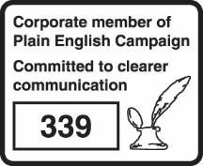
UKHSA supports the UN Sustainable Development Goals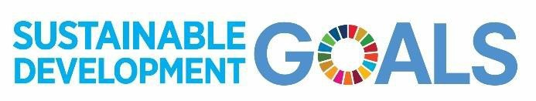

Met Office definition of a heatwave: A UK heatwave threshold is met when a location records a period of at least three consecutive days with daily maximum temperatures meeting or exceeding the heatwave temperature threshold. The threshold varies by UK county.

