School Census Summer 2022 Preparation Guide
PURPOSE: To assist LA maintained schools & PRU in preparing for the School Census Summer 2022.
KEY DATES
Thursday 19 May 2022 | Census Day
Tuesday 24 May 2022 | Deadline for Waltham Forest maintained schools & PRU submit a return to the Local Authority via COLLECT https://services.signin.education.gov.uk

PUPILS TO BE INCLUDED (IN SCOPE): You should include individual data in the return and make sure that all relevant data for them is maintained and up to date for:
- all pupils on the register on census day
- any additional pupils subject to any type of suspension or permanent exclusion in the previous 2 terms
- any additional pupils who attended the school in the previous term for which termly attendance information is required - not for nursery schools
- any additional pupils who had an alternative provision (AP) placement within the collection period (since the last census day) - voluntary from spring census 2022, not applicable for nursery schools
- any additional pupils awarded a bursary since the start of the academic year - spring (and summer) census only and not for nursery, primary and middle schools
- any additional pupils who were recorded as in receipt of learner funding and monitoring since the start of the academic year – not applicable to nursery schools

KEY CENSUS DATA ITEM COLLECTION PERIODS
Item | Period
Term dates | Easter Monday 2022-04-18 to 2022-07-31
Free school meal eligibility | Periods of eligibility for free school meals with:  (a) An FSM eligibility start date and no FSM eligibility end date; or,  (b) An FSM eligibility end date since the previous census, that is on or after  2022-01-21 and up to including the summer census day (2022-05-19)
Learner support (bursary funding for 16-19 year olds) | Any bursaries awarded since the beginning of the 2021 to 2022 academic year (from 2021-08-01) to students who on are either on roll or off roll on census day of 2022-05-19.
Learner Funding and Monitoring (FAM) entity | Any Learner FAM assigned and hours where applicable since the beginning of the 2021 to 2022 academic year (from 2021-08-01) to students who are either on roll or off roll on census day (2022-05-19).
Termly suspensions and permanent exclusions | 2021-08-01 to Easter Sunday 2022-04-17.
Termly attendance | 2022-01-01 to Easter Sunday 2022-04-17.
Alternative provision (AP) placement module – voluntary | any current (open) AP placements, and  any previous placements where the pupil has already left an AP placement between: 2022-01-20 and 2022-05-18 inclusive.
More DfE items info at www.gov.uk/guidance/complete-the-school-census/data-items-2021-to-2022
New, changeD & DELETED DATA ITEMS for SUMMER 2022
- New Data Items
None.

More information at https://www.gov.uk/guidance/complete-the-school-census/changes-from-previous-school-census.
- EXISTING DATA ITEMS
Free school meal eligibility
From the start of the summer term, commencing April 2022 onwards, free school meal eligibility will be permanently extended to children from all groups with no recourse to public funds (NRPF).
These children should be marked as receiving free school meals on the school census, in the same way that children who are eligible for free school meals under the benefits-based criteria would be.
Early years entitlements date of birth range
The Childcare Act 2006 and the Childcare Act 2016 set out that children are only entitled to the free early education entitlements until they reach compulsory school age (the beginning of the term following their 5th birthday). Clarifying date of birth ranges ensures that free entitlement funded hours are not recorded for children who have reached compulsory school age in the summer school census.
Funded universal free entitlement hours:
Date of birth ranges and school type / pupil national curriculum year group | Maximum funded universal free entitlement hours
2 and 3 year olds: Born between 2017-09-01 and 2020-03-31 (inclusive) - all relevant schools and year groups | 15 hours
4 year olds: Born between 2017-04-01 and 2017-08-31 (inclusive) For pupils in national curriculum year groups ‘E1’, ‘E2’, ‘N1’ and ‘N2’ only | 15 hours

Extended free entitlement hours:
Date of birth ranges and school type / pupil national curriculum year group | Maximum funded universal free entitlement and extended free entitlement hours
3 year olds Born between 2017-09-01 and 2019-03-31 (inclusive) - with a valid 30-hour code - all relevant schools and year groups | 15 funded universal free entitlement hours + 15 extended free entitlement hours equals 30 hours
4 year olds Born between 2017-04-01 and 2017-08-31 (inclusive) - with a valid 30-hour code - for pupils in national curriculum year groups ‘E1’, ‘E2’, ‘N1’ and ‘N2’ only | 15 funded universal free entitlement hours + 15 extended free entitlement hours equals 30 hours

- DELETED DATA ITEMS
There are no deleted data items for the 2021 to 2022 school census.

Steps to Producing the School Census Return
The process of producing the School Census can be separated into several steps, some of which might need to be repeated to eliminate validation errors and queries.
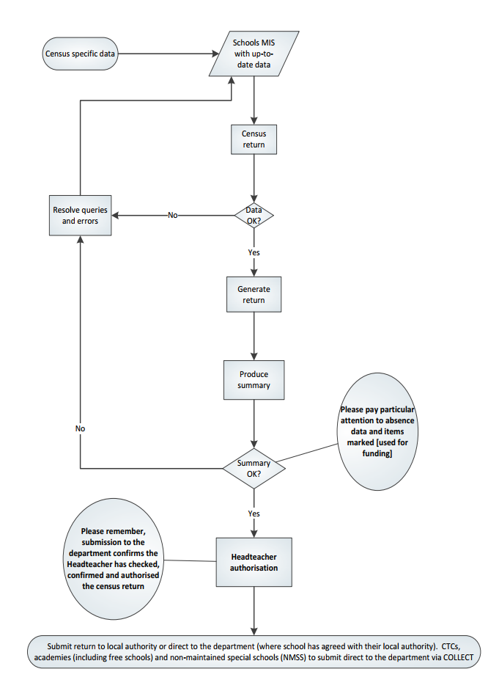

GENERATING, VALIDATING, AUTHORISING AND SUBMITTING THE RETURN
- GENERATING & VALIDATING

All relevant pupil data has been entered and updated in your management information system (MIS) before the school census return is created.
Your MIS will have validation which will help you to identify and correct errors in your data before you generate your return. Follow your MIS support provider instructions to create, validate and authorise the return.
Schools should contact their MIS support provider for specific guidance on generating and validating the return.
- AUTHORISING
Your MIS will automatically generate a summary of the data in the school census return that will:
- allow you to check that that the data is accurate and complete before sending it to the Headteacher; and
- allow the Headteacher authorising the return to check it is accurate and complete before submitting it to the local authority or DfE.
It is strongly recommended that you inspect the MIS summary report carefully, paying particular attention to the sections that might show that some individual pupil data was not entered onto the system before generating the return such as free school meal eligibility, the number of pupils with SEN, data items marked [used for funding] and absence data etc.
The Headteacher is responsible for reviewing and authorising census data before it is submitted.
- SUBMITTING
Maintained schools including pupil referral units submit data to the Local Authority using COLLECT for further validation and approval before being submitted for DfE authorisation.
The act of submitting the data automatically confirms the return as authorised by the Headteacher.
To use COLLECT to submit your school census data, you will need to log in via DfE Sign-in https://services.signin.education.gov.uk. Contact your school approver, if you want to request a DfE sign-in username or password so you can access COLLECT, or ‘school census’ is not on the list of collections you can see in COLLECT.
All school census COLLECT errors are to be corrected. All queries checked and either amended (if there is an issue); or a notepad explanation is provided in the ‘return level notes’ section of COLLECT. A DFE list of acceptable notepad entries is at www.gov.uk/guidance/complete-the-school-census/check-your-data (section ‘Adding explanatory notes for queries’).
If the DfE has any queries about your return or any of the notes added, they may also add a note to the ‘return level notes’ section of COLLECT. It is worth checking back to make sure your return is authorised.
More DfE guidance on submitting the return can be found at www.gov.uk/guidance/complete-the-school-census/submit-your-data; and checking at www.gov.uk/guidance/complete-the-school-census/check-your-data

‘Dry Run’, Testing & COLLECT familiarisation
Schools should take the opportunity to do a ‘dry run’ of their school census return. The purpose of a dry run is to provide details about any corrections that need to be made to your data to make it acceptable for inclusion. So that you are aware of any potential issues, it is advisable to do this as early as possible, even if you know that your data has not yet been fully prepared or checked. Contact your management information system (MIS) Support Provider for any procedural guidance to facilitate a dry run.
A ‘beta’ release of the 2022 summer school census live COLLECT blade is available for you to become familiar with. This will remain available until 4pm on Friday 13 May at which point the blade will be removed and cleared out in advance of the start of the live collection on Thursday 19 May. The DfE would strongly recommend that, if possible, all schools take the chance to load a file output from their management information system (MIS) into COLLECT during the familiarisation process. This will allow schools to check that all the required data is being output correctly from their MIS into the summer census return, and whether any validation errors or queries are generated against the data when loaded into COLLECT which need to be resolved before the collection goes live. This will be especially important for any schools completing the summer school census for the first time.

COLLECT familiarisation will take place on the same system as the live collection and, therefore, can be accessed by logging into COLLECT via DfE sign-in in the same manner as you would for the live collection.
WHO TO CONTACT?

Contact | Support
George Nyamundanda (Senior Analyst)  Telephone: 020 8496 3923 E-mail: george.nyamundanda@walthamforest.gov.uk | School Census data collection and return queries.
Andrew Bowerman (Performance Analyst)
Telephone: 020 8496 3924 E-mail: andrew.bowerman@walthamforest.gov.uk
Oznur Dhaouadi (Data Quality Officer)
E-mail: Oznur.Dhaouadi@walthamforest.gov.uk
Department for Education (DfE)  https://form.education.gov.uk/service/Data-collections-service-request-form | DfE Data collections service request form.

SUMMER 2022 SCHOOL CENSUS – CHECKLIST
This checklist indicates some of the tasks to undertake to prepare for the school census. Your MIS Support Provider may provide a more specific procedural list of tasks that you should follow.
MIS Permissions: Check with your System Administrator/Manager that you have the appropriate permissions to run the School Census and record associated data.
MIS is the correct version? Upgrade to the correct MIS version to run School Census.
Dry Run/COLLECT Familiarisation: Carry out a dry run to determine what information needs to be updated.
School information: Check school level information.
Pupils' basic details: Check the pupils' basic details, e.g., name, date of birth, gender, etc
Leavers: Check that leavers and re-admissions have been recorded.
Registration details: Check the pupils' various registration details, e.g., enrolment status, admission date, year taught in, UPN, part-time information, Alternative Provision Placement, etc
Attendance: Check attendance data.
Enrolment Status – dual registrations: Pupils on roll at your school and another school/PRU must have the correct enrolment status recorded (i.e., M = Dual Main or S = Dual Subsidiary).
FSM: Check free school meal eligibility information.
All KS1 pupils can have school lunch due to their Universal Infant Free Meal. Only include KS1 pupils as FSM eligible if they also meet the FSM eligibility criteria for family income.
It is not expected that FSM end dates will be entered by schools due to transitional arrangements to minimise the impact of Universal Credit rollout.
- any claimant who was in receipt of free school meals on 31 March 2018 should continue to receive free school meals until the end of the universal credit roll out period, and then until their phase of education ends. This covers until at least Summer 2023 and applies even if their circumstances change, and they would no longer meet the eligibility criteria.
- any claimant who gained eligibility for free school meals from 1 April 2018 will continue to receive free school meals until the end of the universal credit rollout period, and then until their phase of education ends. This covers until at least Summer 2023 and applies even if their circumstances change, and they would no longer meet the eligibility criteria.

You should not enter end dates unless:
- a parent has said that they do not wish the child to be recorded as eligible for free school meals and receive a free school meal.
- a pupil transfers from another UK country – their non-English free school meals must have an end date.
- a parent notifies the school that their support under the Immigration & Asylum Act 1999 or the pension credit has ended.
Full-time/part-time status for pupils who are not of statutory school age: Please ensure that each pupil in these year groups is correctly shown as full-time or part-time.
Funded hours for pupils aged 2, 3 or 4: Check the funded entitlement hours information. DfE information is at www.gov.uk/guidance/complete-the-school-census/data-items
Hours at setting for pupils aged 2, 3 or 4: Check that it is the total of:
- any hours funded under the free early education entitlements, plus
- any hours funded under extended funded entitlement (for working parents), plus
- any additional hours of education funded from other sources such as parents.
First Language: Check First language information.
Learner Funding and Monitoring (FAM) details: Update details as required by the DfE.
Post Looked After pupils (previously ‘Adopted from care’): Check information collected for pupils who are on-roll on census day. Identifies those children on roll on census day who were looked after immediately before adoption or prior to being subject of a residence or special guardianship order. Used for funding purposes.
Pupil SEN provision: Check special educational needs information. SEN provision is collected for all pupils on roll on census day.
Termly suspensions and permanent exclusions: Check information.
Top-Up Funding Indicator: Pupils for whom the school receives top-up funding from the local authority. Most pupils for whom top-up funding is paid will have an EHCP. Please check pupils meet the funding threshold. Refer to the section in the DFE Guidance. Top-up funding indicator [used for funding]: www.gov.uk/guidance/complete-the-school-census/data-items
Unique Learner Numbers (ULN): Pupils who are age 14+ on census day must have a ULN.
Unique Pupil Numbers (UPN): If you have pupils with a temporary UPN or new pupils that require a UPN, check whether they already have a permanent UPN assigned to them.
Home address: Check the pupils' home address information
Check Early Years information: Applicable to schools that have 2, 3 or 4 year old pupils only

