Summary Report
S11 Audit 2021

The audit was completed between 26th May 2021- 5th June 2021 following some schools and colleges contacting the team concerned about Harmful Sexual Behaviour and evidencing their response to this. Ofsted were tasked by the DfE to undertake a review of Harmful Sexual Behaviour in schools and colleges and planned to contact schools to evidence safeguarding practice related to this. As such we determined that a focused S11 audit on this area would support schools to identify good practice and areas that we wished to strengthen. In addition to this, schools and colleges were asked to give feedback on how they have incorporated trauma informed practice into their response to concerns.

All schools in Waltham Forest completed the S11 audit. Schools were informed that 20% of schools would be selected at random for a face-to-face audit. Unfortunately, due to the pressures of COVID a face- to- face audit could only be completed on 10% of schools and colleges.

All staff were asked to complete an online survey. Primary and SEND students were asked to have a focussed discussion based upon questions given to schools. Secondary aged students were asked to complete an online survey.
The main themes that were apparent from the audit feedback was the need for a policy on Harmful Sexual Behaviour, support in improving direct practice in schools and colleges and the impact on the voice of the child. Secondary aged students were able to communicate how they felt through the survey which schools and colleges were encouraged to continue outside of the audit.

Author: Chloe Pettigrew, Assistant Team Manager LADO & Safeguarding in Education
Overview and findings

The first part of the audit asked questions centred on foundation safeguarding practice and provision. Most schools stated that they have the basics in place at a minimum and from visiting some of the schools I can testify to this.

Areas of development for schools in this area is around the sharing of policy to children and parents. 67% of schools stated that they did not make a child friendly policy and 45% stated that they do not allow parents and children to contribute to the policy. This may be because most schools use the model safeguarding policy that the borough provides, it is important to note that this does not mean that schools cannot develop the policy further.

As this has been identified as an area for development, we will provide a template of a questionnaire that can be sent to all parents encouraging them to read the safeguarding policy and provide their feedback. Schools can use an online portal to make it easier to filter information received and will also allow them to make modifications to suit parents with an additional language.

SIE team actively encourages schools to have a student voice panel within their school. Student panels should review all policies that are presented to them which can be facilitated by the member of staff that facilitates the panel. SIE will utilise the DSL forum for schools to share how they use student voice within their school which will help to inspire and support other schools in creating one for themselves.

57% of schools stated that they do not provide safeguarding information and training to external providers. This was noted to be a concern in the schools that I visited, therefore, face to face or written feedback was provided to individual schools outlining what needs to be completed which is not dissimilar to processes that they already have in place for their existing members of staff. In addition, a tool was sent to all schools that has KCSIE translated into several different languages that schools could use for support staff who may not have English as their first language. Schools now have an understanding that all external providers should sign to state that they understand and will follow the school’s safeguarding policy.

24% of schools stated that they had not provided unconscious bias training to their staff to ensure that staff are aware of the impact this has upon children. This may be due to a lack of understanding of the impact that unconscious bias has on practice. We would like to address this concern by facilitating training for schools in this area to enhance knowledge and understanding.

The second part of the audit focussed on Harmful Sexual Behaviour (HSB). Within this section it was evidenced that many schools have robust policy in place to support with a response to HSB. All schools noted that they knew how to respond to HSB including multi- agency working, engaging parents, and understanding the support that must be provided to the alleged perpetrator as well as the victim.

Training is offered to schools on HSB which is co-ordinated by the Harmful Sexual Behaviour lead for the borough. AIM assessment training is facilitated and all schools should have at least one member of staff who is AIM trained. The requirement for renewal of this is 2 years. The HSB lead also attends the DSL forum regularly to give an update on themes that are present within the borough and how schools can respond to these concerns.

Schools must refer all new cases of HSB to MASH which the HSB lead has oversight of and can provide direct case work and consultation to schools when incidents arise and in addition to this, a risk assessment is being created by the Council to address how schools mitigate risk within their setting. The Hub website page on Safeguarding and Wellbeing also has resources for school on how to manage HSB which can be found here The Hub- HSB.

20-25% of schools stated that they were not sure that students knew what a DSL would do when a disclosure is made and that students did not know the meaning of HSB. It was highlighted that most of the schools who responded in this way were primary schools. In the responses to those schools, it was highlighted that whilst primary aged students may be too young to hear explicit language, there are ways of educating children to ensure that they understand and can identify harmful behaviour and when they are made to feel uncomfortable.

Resources are available on The Hub website page that have been developed by NSPCC and CAFCASS which can offer additional support to schools and colleges.

The third part of the audit focussed on Trauma Informed Practice (TIP). Most, if not all schools felt that they have a good response to trauma experienced students within their school. Most schools did not have a specific policy however they felt able to respond to the needs of children who were presenting with trauma behaviours.

The Council currently have a TIP systems group which focusses on scoping what is available council wide and aiming to identify and co-ordinate services available. It also seeks to identify services that are being proposed and where there are funding concerns and/ or gaps.
There is also a VAWG funded project which is aimed at developing and delivering a tailored menu of support to identified schools. Within these groups there will be active discussions about what is needed and what can be made available to schools.

Feedback from primary aged and SEND students were facilitated by class teachers. The response to this was poor with a small number of staff members completing this activity with their students. Of the responses received, pupils reported feeling happy and safe within school.

The low number of responses could have been due to the lack of preparation that schools had and the timing of the audit taking place. Many schools complained within a steering group that the timing of the audit was poor especially after a very difficult year managing COVID pressures and a number of other audits being required for them to complete. Service Lead’s within the Council have agreed to co-ordinate audits that schools are expected to complete to ensure that schools do not feel pressured to complete pieces of work at the same time.
If schools wish to develop the voice of the primary/ SEND aged students, this can be developed using helpful tools by Barnardo’s. Please see the link to support this Barnardo’s- Finding Your Voice.

When reviewing the feedback from all schools, the vast majority of primary aged and SEND students reported that they feel safe when they are in school. All feedback indicated that children knew who to go to if they needed help. Students largely stated that they notice bullying and always speak to a teacher about it with a very small number stating that they did not feel able to report out of fear of reprisals. These answers came from year 6 students which would be a more appropriate comment to make given their understanding and development.

There were teachers who commented stating that they needed to explain what bullying meant to their students. Therefore, suggesting that bullying needs to be a topic that is reviewed in school regularly so to ensure that all students understand what this is.

Schools should continue to use anti-bullying week to raise awareness of bullying within their school utilising the support that they can receive from the Education Service and via The Hub information which can be found on The Hub here Bullying.

3316 of secondary aged students completed the online questionnaire given. It was felt that direct questions around HSB should not have been asked of students given the feelings that these questions could provoke. Therefore, questions were broadly looking at how safe students feel within school and how comfortable they feel reporting concerns. Most of the students who completed the surveys were in KS3. Most students stated that they felt somewhat safe whilst in school.

There may be students within schools who feel uncomfortable sharing that they feel unsafe when they are in school. This, again links to the student voice within the school becoming prominent and well supported by teachers.
The following findings are collated from all secondary students across Waltham Forest.

How safe do you feel in school?
- Very safe 940 – 28%
- Somewhat safe 1522 – 46%
- Neither safe nor unsafe 654 – 20%
- Somewhat unsafe 117 – 4%
- Very unsafe 83 – 3%
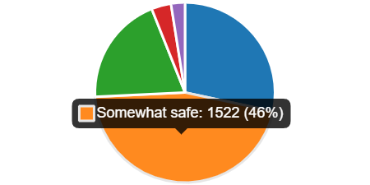

82% of students said they have someone they can go to if they are worried about an issue at home or at school. Only 61% of students feel confident that if a concern was raised with a member of staff that it would be taken seriously. This needs to be addressed by all secondary students to reinforce the importance in disclosing and assuring that all disclosures will be taken seriously.

Schools can reinforce this by regular assemblies, newsletters, and discussion topics within RSHE.

Do you know who to go to if you feel unsafe or worried at school or about something that has happened at home?
- Yes 2717- 82%
- No 599 - 18%
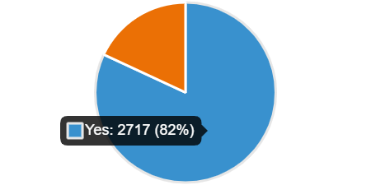
Do you feel confident when concerns are raised with a member of staff that the issue will be addressed?
- Yes 2009 - 61%
- No 1307 - 39%
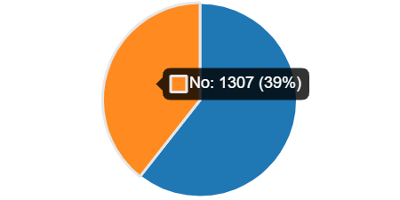

In terms of whether students feel comfortable talking to a member of staff, 26% said they would, 20% said they would not and 54% said they were unsure.

These statistics draw further attention to the importance of building relationships with students through listening and incorporating them into student voice initiatives. Students respond well to seeing evidence of concerns being raised and actioned through assemblies and other forums. This will improve confidence that students have in staff and will lead to students feeling more able to share their experiences.

Would you feel comfortable talking to a staff member if you ever felt mis- treated inside or outside of school?
- Yes 858- 26%
- No 659- 20%
- Maybe 1799- 54%
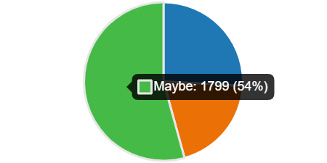

65% of students stated they have noticed bullying within their school and the most common themes are ongoing name calling, bullying based upon appearance and social media. These areas of concern should be addressed within PSHE/ SRE lessons.

Schools should seek support on how to manage bullying within their school through Education Services and this web page Bullying.

What type of bullying?
- Ongoing name calling 1660
- Homophobic/ transphobic 1054
- Racial abuse 772
- Based on appearance e.g. hair, clothing 1260
- Academic level e.g. very smart or struggles with school work 893
- Sexual abuse 336
- Family issues e.g. comments about personal life 743
- Social media 1042
- Verbal 235

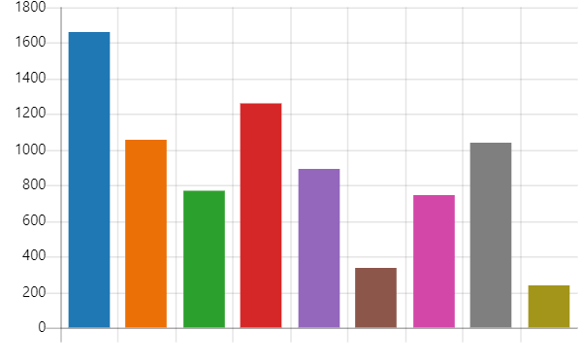
Conclusion
Whilst schools have demonstrated that they have a good working knowledge on how to respond to concerns around HSB, what is interesting is that students have ranked sexual harm as a form of bullying quite low in their survey response.
During SIE visits to schools to complete on-site audits, students have been able to identify within discussion that they have noted incidents of HSB within their school yet rarely report these to school staff. This would seem to indicate a “normalised” response to incidents of this nature and concurs with the picture nationally. There needs to be a significant culture change in terms of the recognition and response to HSB within the educational environment.
Schools should utilise the support offered through the Harmful Sexual Behaviour lead who is willing to support schools in addressing wider concerns around HSB. It is also recommended that all schools appoint a lead for HSB who is tasked with managing support that is offered to all students and co-ordinating support for targeted students. The SIE team will use DSL forums to share practice that has been identified in schools that are responding well to HSB concerns who are using this method of practice.
It is difficult to determine why students do not feel comfortable enough raising these concerns with teachers. However, this highlights the need for schools to continue raising an awareness of acceptable and unacceptable behaviour in order to change the culture within their school settings.
Schools that have a strong student voice and where respect is felt among all student’s evidence how relational shifts in the school help to support students to feel safe in confiding within staff. Good practice of how to implement this will be shared with schools in DSL forums.

Action | By When
HSB abuse model policy developed and sent to all schools and colleges | Completed
VAWG Task and Finish Group to support individual schools | Started and ongoing
Termly DSL forums to continue to enhance practice and development addressing themes such as HSB strategies, good practice, LADO themes and analysis and safeguarding concerns. We will have guest speakers to present in these areas. | Ongoing termly
Schools and colleges to be encouraged to continue facilitating surveys/ questionnaires to strengthen the student voice which will be facilitated through forums. | Termly
Safeguarding in Education website page to be regularly updated so that schools can have access to all support services within the borough. | Bi-monthly review and linked to VAWG and HSB pages
Safeguarding in Education traded service to facilitate visits as required with schools to support DSL’s, offer consultation, supervision. | As required
Trauma informed training to be offered to school | Twice per year
Trauma informed practice resources to be developed and collated and placed on the HUB | Trauma informed practice group to develop and ensure that this is placed on the HUB to be accessible to schools and colleges

