DEPARTMENT FOR EDUCATION (DFE) EARLY YEARS CENSUS 2022 RETURN: GUIDE

For the attention of the Head/Manager of the funded early years setting
PURPOSE
The purpose of this guide is to assist funded early years settings to provide the necessary information to Waltham Forest’s Early Years Provider Portal to enable the completion of this statutory return
KEY DATES
Thursday 20 January 2022 | Census Day. The census will collect data on all children taking up free provision during census week.
Friday 21 January 2022 | Providers must ensure CHILD data is accurately maintained on Waltham Forest’s Early Years Provider Portal to reflect funded 2, 3 and 4-year-old children receiving free early education in their setting during census week (w/c 17th January 2022), as directed by the Early Years Team.  See section 1) CHILD-LEVEL DATA.
Thursday 27 January 2022 | Providers must complete the DFE EY Census 2022 Provider Data Form on Waltham Forest’s Early Years Provider Portal:  - for additional information required for the statutory return.  See section 2) PROVIDER INFORMATION FORM; and  - to authorise and submit the form information to the Local Authority.  See section 3) MANAGER AUTHORISATION/SIGN-OFF.

SCOPE
All English providers of free early education in the private, voluntary and independent sectors are within the scope of the early years census. Data is only required from early years providers that have funded 2, 3 and 4-year-old children during the week beginning 17 January 2022.
For the purposes of this collection, the DfE define ages as:
- a 2-year-old has a date of birth between 1 January 2019 and 31 December 2019
- a 3-year-old has a date of birth between 1 January 2018 and 31 December 2018
- a 4-year-old has a date of birth between 1 January 2017 and 31 December 2017

- CHILD-LEVEL DATA
The information required for the statutory return will be based on what your setting has recorded to Waltham Forest’s Early Years Provider Portal, as directed by the Early Years Team for Spring 2022. Ensure that all child information is completed (i.e., child ethnicity) for all eligible 2, 3, 4-year-old children who you are claiming for.
- On the “Child Details” tab, ensure the correct “SEN COP Stage” is selected from the dropdown menu. Where the child is not in receipt of EHCP or SENIF funding, then select “No Special Educational Need” from the dropdown menu.
- On the “Funding Details” tab, ensure the “Present during Census” box are ticked where relevant, to indicate all children taking up free provision during census week. Please record the normal situation during the week. If children are temporarily absent, for example, sick or on holiday, include them. If the provider was temporarily closed, record the situation which would have applied during the week. The Department for Education (DFE) COVID-19 related support for submitting an early years census 2022 return guidance explains the different scenarios and how to record them.
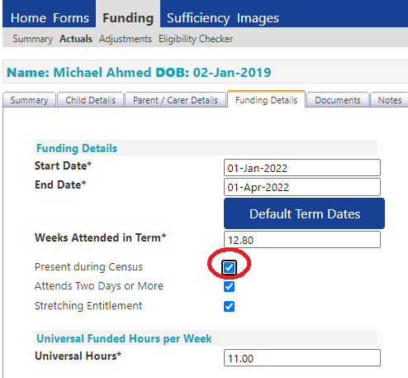
- PROVIDER INFORMATION FORM
Record the normal situation during the census week. If children are temporarily absent, for example, sick or on holiday, please include them. If the provider was temporarily closed, record the situation which would have applied during the week.
- Sign into the Waltham Forest’s Early Years Provider Portal.
- Select the 'Forms' tab, and
- Select the link to the form i.e., 'DFE EY Census 2022 Provider Data' to generate a form to provide the additional information required for the statutory return.
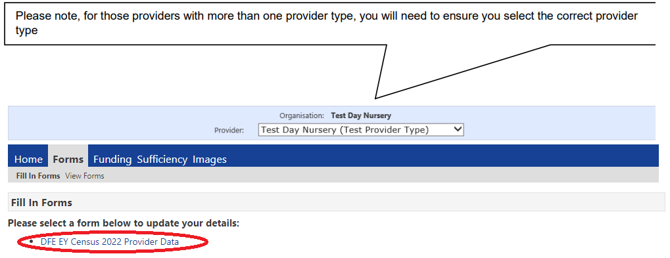
- PROVIDER INFORMATION AND OPENING & CLOSING TIMES
Section 1A: Provider details - This section is for information only. Contact the Early Years Team if any if this information needs to be amended.
Section 2A: Category of Provider - This section is for information only. Contact the Early Years Team if any if this information needs to be amended.
Section 2B: Type of Care Provided (to be completed by “Private” or “Voluntary” providers only)
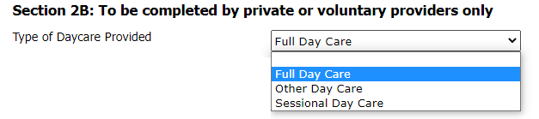
This section is to be completed for “Private” or “Voluntary” providers only (as indicated in Section 2A). If not “Private” or “Voluntary” leave blank. The ‘Type of care’ is specified in your OFSTED registration document.
Section 2C: If you are not open on the census date, record your hours during a normal week.
- Are you open 24/7? (Yes/No)
If you are open/offer a childcare service for 24 hours a day and 7 days a week – i.e., you do not close, select 'Yes'. If you are not open/offer a childcare service for 24 hours a day and 7 days a week select 'No'
- Daily Opening and Closing Times (Monday – Sunday):
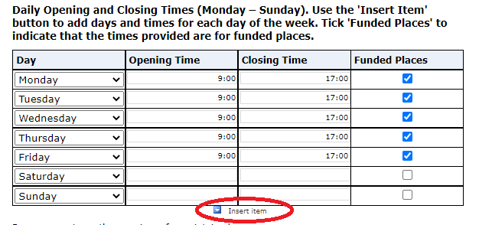
Use the ‘Insert Item’ or arrow on the left-hand side of table (if available)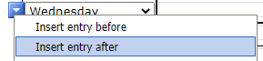to insert a new row in the table (if required).
All days of the week (Monday – Sunday) should have a corresponding Opening and Closing time provided, as per the screenshot below. For each day open, the ‘Funded Places’ box should be ticked to indicate times provided are for funded places.
For days where the provision is not open, leave the Opening Time and Closing Time blank and ‘Funded Places’ unticked.
- Do you operate on the premises of a maintained school or have a contract or partnership agreement with a maintained school? (Yes/No)
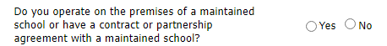
If the provision operates on the premises of a maintained school or have a partnership with a maintained school, select 'Yes'. If you do not operate on the premises of a maintained school and do not have a partnership arrangement with a maintained school, select 'No'. This question must be completed.
- Do you work in partnership with another PVI establishment to provide funded early education? (Yes/No)
If you work in partnership with another establishment to provide funded early education, select 'Yes'. If you do not work in partnership with another establishment to provide free early education, select 'No'. This question must be completed.
- How many weeks are you open each year?
Indicate the total number of weeks you are open per year, to the nearest half week (where a half week is represented by 0.5). This box must be completed.
- How many weeks in the current calendar year is the provider open and funded by the local authority?
Indicate the number of weeks you are open in the current calendar year and funded by the Local Authority, to the nearest half week (where a half week is represented by 0.5). This box must be completed.

- STAFF INFORMATION
All boxes must be completed and a '0' inserted in the box(es) where no staff meet the qualification criteria.

- Total number by headcount of staff at provider who work with children under 5?

- Number, by headcount, of staff that have a full and relevant early years level 2 qualification who work with children aged under 5?

- Number, by headcount, of staff with a full and relevant early years level 3 qualification and NOT in a managerial role who work with children aged under 5?

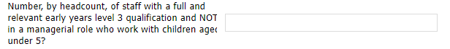

- Number, by headcount, of staff with a full and relevant early years level 3 qualifications and IN a managerial role who work with children aged under 5?

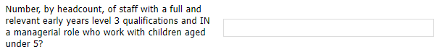

- Number, by headcount, of staff with qualified teacher status who work with children aged under 5?

- Number, by headcount, of staff with early years professional status who work with children aged under 5?

- Number, by headcount, of staff with early years teacher status who work with children aged under 5?

Note:
- Only the highest level qualification for each member of staff is to be recorded, double counting must not occur (e.g., a member of staff has a level 2 and level 3 – only the level 3 qualification is to be recorded). The order the qualifications are to be returned are as follows:
QTS
EYTS
EYPS
Level 3 – Managerial (i.e., setting manager. This does not include room leaders or senior members who are not the setting manager)
Level 3
Level 2

- Volunteers should not be included in the staff numbers.
- Childminders should include themselves in staff numbers. Childminders are considered to have a managerial role, so should be included in Nos of staff with a level 3 Managerial – unless they hold a higher level of qualification, in which case they should be recorded under the relevant qualification (EYPS, EYTS, QTS).
- Staff with graduate level qualifications excluding EYPS, EYTS, QTS (for example BA Early Childhood Studies, Foundation Degree etc) should be recorded as a level 3 as their qualifications allow them to practice at level 3 staffing ratios.

- NUMBER OF FUNDED AND UNFUNDED CHILDREN BY AGE (AGE AS AT 31ST DECEMBER 2021)
‘Unfunded Hours’ are those hours which the parent/carer pays for and are not funded through the FEEE.
All boxes must be completed and a '0' inserted in the box(es) where none are at the age.
- Number of 2-year-olds?
- Number of 3-year-olds?
- Number of 4-year-olds?

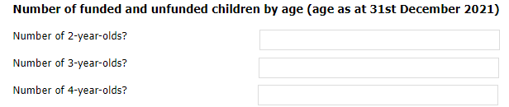

- MANAGER AUTHORISATION/SIGN-OFF AND SUBMISSION
- MANAGER AUTHORISATION/SIGN-OFF
Once all information has been completed the form is ready for authorisation by the Head of the provision.

Select the ‘Next Page’ button in the form to go to the Authorisation page.
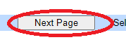
Tick the box to confirm that all the information in the form is correct and up to date. Ticking the box also confirms that the child level data submitted via the Early Years Providers Portal is also correct and up to date.
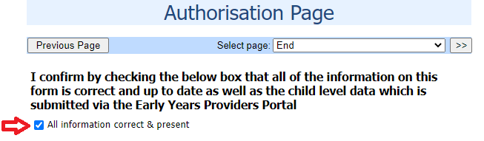

- SUBMITTING THE FORM TO THE LOCAL AUTHORITY
Once the form has been authorised, click the ‘Submit Form’ button to submit the form to the Local Authority.
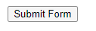
Once you have submitted the form you will see a green tick on screen to indicate the Early Years Census form has been submitted successfully.

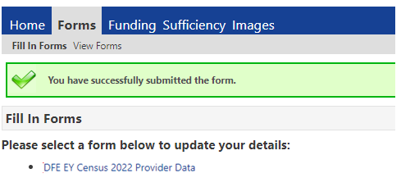

If you select 'View Forms', you will see your Early Years Census form is now 'pending' – showing the time/date you have submitted the form:
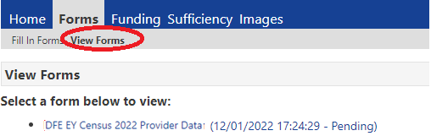

Once your Early Years Census form has been authorised, the form will show 'Authorised'– showing the time/date the form has been authorised.
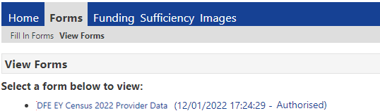

SUPPORT
Name (Role) | Telephone | Email
George Nyamundanda (Senior Analyst) | 020 8496 3923 | george.nyamundanda@walthamforest.gov.uk
Andrew Bowerman (Analyst) | 020 8496 3924 | andrew.bowerman@walthamforest.gov.uk
Oznur Dhaouadi (Data Quality Officer) | 020 8496 3922 | oznur.Dhaouadi@walthamforest.gov.uk

