School Census Autumn 2021 Preparation Guide
PURPOSE: To assist LA maintained schools & PRU in preparing for the School Census Autumn 2021.
KEY DATES
Thursday 7 October 2021 | Census Day
Tuesday 12 October 2021 | Deadline for Waltham Forest maintained schools & PRU submit a return to the Local Authority via COLLECT https://services.signin.education.gov.uk

PUPILS TO BE INCLUDED (IN SCOPE): You should include individual data in the return and make sure that all relevant data for them is maintained and up to date for:
- all pupils on the register on census day
- pupils no longer on roll who:
- were subject to any type of suspensions or permanent exclusion in the previous 2 terms - not required from nursery schools
- attended the school in the previous term for which termly attendance information is required - not required from nursery schools
- attended the school in the previous academic year and for which learning aims are submitted - for secondary, all-through and PRU or AP schools in the autumn term only
- have been in receipt of learner funding and monitoring since the start of the current academic year - not required from nursery schools

KEY CENSUS DATA ITEM COLLECTION PERIODS
Item | Period
Term dates | Start of the autumn term (from 01/08/2021) to 31/12/2021
Free school meal eligibility | Periods of eligibility for free school meals with:  (a) An FSM eligibility start date and no FSM eligibility end date; or,  (b) An FSM eligibility end date since the previous census, that is, on or after 21/05/2021 and up to and including the autumn census day (07/10/2021).
Learner Funding and Monitoring (FAM) entity | Any Learner FAM assigned since the beginning of the 2021 to 2022 academic year (from 01/08/2021) to students who are either on roll or off roll on census day (07/10/2021).
Termly suspensions and permanent exclusions | 01/01/2021 to 31/07/2021.
Termly attendance | First half of the summer term. From Easter Monday 05/04/2021 to the Sunday 30/05/2021 before spring bank holiday.
Summer second half term attendance | From spring bank holiday Monday 31/05/2021 to 31/07/2021.
Post-16 learning aims | Current academic year: From 01/08/2021 for pupils with a status of ‘C’ (current – single registration) or ‘M’ (current main – dual registration) who have been on roll and in actual NC Year 12 or above.  Previous academic year: From 01/08/2020 to 31/07/2021 inclusive for pupils who were on roll at any point in actual NC Year 12 or above. For those pupils with a pupil status of ‘C’ or ‘M’ at the time of the learning aims.
More DfE items info at www.gov.uk/guidance/complete-the-school-census/data-items-2021-to-2022
New, changeD & DELETED DATA ITEMS for Autumn 2021
- New Data Items
Learner Funding and Monitoring (FAM): Is used to identify additional attributes of the learner to inform funding or for additional monitoring. In the 2021 to 2022 academic year it is used to identify pupils in receipt of elements of the education recovery package and should only be entered into systems and returned to DfE if any attributes apply to the pupil. Data is to be returned for pupils who are either on roll on census day or became off roll since the start of the academic year.
New Item | Description
Learner funding and monitoring (FAM) type | Collected from autumn 2021. This data item records the type of funding and monitoring.  As there is only one type for the 2021 to 2022 academic year, this should be defaulted in management information systems (MIS).  Type Description  NLM National Learner Monitoring
Learner funding and monitoring (FAM) code | Collected from autumn 2021. Indicates the specific element of the category being recorded. Collected alongside the learner FAM type.  Code Description Pupils / school types applicable  01 In receipt of school led tutoring programme Schools: All schools (except Nursery), with appropriate year group or age-ranges. Only applicable to pupils and in NC Year Actual 1-11 or aged 5 to 15 (as at 2021-08-31) in NC Year Actual ‘X’ for special schools.  21 Learner in receipt of 16-19 tuition fund Schools: Secondary, all-through and PRU / AP with appropriate year groups. Pupils: NC Year Actual 12 and above with current single registration (‘C’) or current main dual registration (‘M’). PRU / AP for any pupils with the following enrolment status: ‘C’, ‘M’, ‘F’ or ‘O’.  22 Learner repeating up to one full final year of 16-19 funded provision Schools: Secondary, all-through and PRU / AP with appropriate year groups. Pupils: Only applicable to pupils in NC Year Actual 13 or above, with current single registration (‘C’) or current main dual registration (‘M’). PRU / AP for any pupils with the following enrolment status: ‘C’, ‘M’, ‘F’ or ‘O’.

More information about the learner funding and monitoring data items can be found at www.gov.uk/guidance/complete-the-school-census/data-items-2021-to-2022#learner-funding-and-monitoring-fam
- CHANGED DATA ITEMS
Changed Data Item | Description | Schools applicable | More information
Exclusions module | From autumn 2021, in line with government advice, fixed-term exclusions will be referred to as suspensions. | Not required from nursery schools | www.gov.uk/guidance/complete-the-school-census/data-items-2021-to-2022#suspension-or-permanent-exclusion
Programme aims | From autumn 2021, programme aims will be collected for both on and off roll pupils. | Secondary, All-through & Pupil Referral Unit | www.gov.uk/guidance/complete-the-school-census/data-items-2021-to-2022#programme-aim
Maths and English prior attainment year group | Data items relating to prior attainment at the end of year 11, ‘maths GCSE prior attainment year group’ and ‘English GCSE prior attainment year group’, have been renamed to ‘maths GCSE prior attainment year 11’ and ‘English GCSE prior attainment year 11’ to improve clarity. | Secondary, All-through & Pupil Referral Unit | www.gov.uk/guidance/complete-the-school-census/data-items-2021-to-2022 (‘Post-16 student data' section).

- DELETED DATA ITEMS
There are no deleted data items for the 2021 to 2022 school census.

Steps to Producing the School Census Return
The process of producing the School Census can be separated into several steps, some of which might need to be repeated to eliminate validation errors and queries.
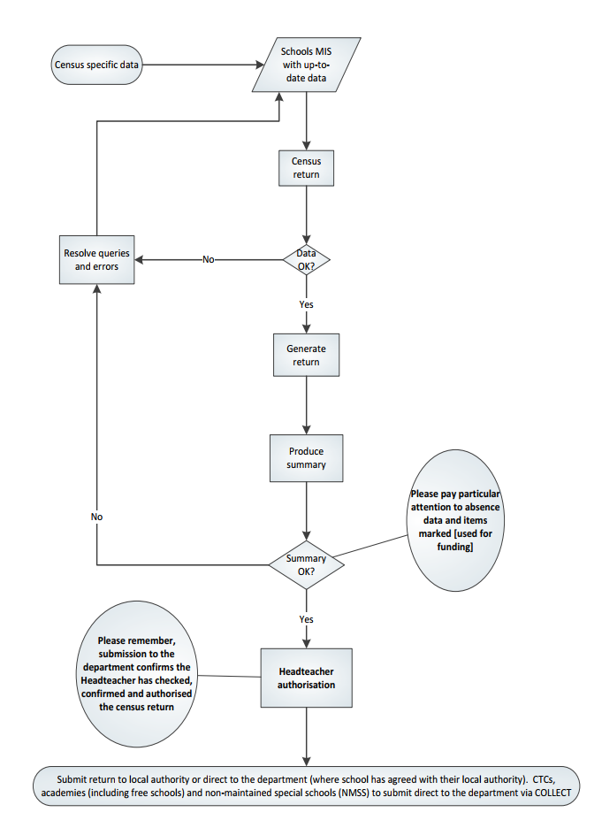

GENERATING, VALIDATING, AUTHORISING AND SUBMITTING THE RETURN
- GENERATING & VALIDATING

All relevant pupil data has been entered and updated in your management information system (MIS) before the school census return is created.
Your MIS will have validation which will help you to identify and correct errors in your data before you generate your return. Follow your MIS support provider instructions to create, validate and authorise the return.
Schools should contact their MIS support provider for specific guidance on generating and validating the return.
- AUTHORISING
Your MIS will automatically generate a summary of the data in the school census return that will:
- allow you to check that that the data is accurate and complete before sending it to the Headteacher; and
- allow the Headteacher authorising the return to check it is accurate and complete before submitting it to the local authority or DfE.
It is strongly recommended that you inspect the MIS summary report carefully, paying particular attention to the sections that might show that some individual pupil data was not entered onto the system before generating the return such as free school meal eligibility, the number of pupils with SEN, data items marked [used for funding] and absence data etc.
The Headteacher is responsible for reviewing and authorising census data before it is submitted.
- SUBMITTING
Maintained schools including pupil referral units submit data to the Local Authority using COLLECT for further validation and approval before being submitted for DfE authorisation.
The act of submitting the data automatically confirms the return as authorised by the Headteacher.
To use COLLECT to submit your school census data, you will need to log in via DfE Sign-in https://services.signin.education.gov.uk. Contact your school approver, if you want to request a DfE sign-in username or password so you can access COLLECT, or ‘school census’ is not on the list of collections you can see in COLLECT.
All school census COLLECT errors are to be corrected. All queries checked and either amended (if there is an issue); or a notepad explanation is provided in the ‘return level notes’ section of COLLECT. A DFE list of acceptable notepad entries is at www.gov.uk/guidance/complete-the-school-census/check-your-data (section ‘Adding explanatory notes for queries’).
If the DfE has any queries about your return or any of the notes added, they may also add a note to the ‘return level notes’ section of COLLECT. It is worth checking back to make sure your return is authorised.
More DfE guidance on submitting the return can be found at www.gov.uk/guidance/complete-the-school-census/submit-your-data; and checking at www.gov.uk/guidance/complete-the-school-census/check-your-data

‘Dry Run’ & Testing
Schools should take the opportunity to do a ‘dry run’ of their school census return. The purpose of a dry run is to provide details about any corrections that need to be made to your data to make it acceptable for inclusion. So that you are aware of any potential issues, it is advisable to do this as early as possible, even if you know that your data has not yet been fully prepared or checked. Contact your management information system (MIS) Support Provider for any procedural guidance to facilitate a dry run.
WHO TO CONTACT?

Contact | Support
George Nyamundanda (Senior Analyst)  Telephone: 020 8496 3923 E-mail: george.nyamundanda@walthamforest.gov.uk | School Census data collection and return queries.
Andrew Bowerman (Performance Analyst)  Telephone: 020 8496 3924 E-mail: andrew.bowerman@walthamforest.gov.uk | School Census data collection and return queries.
Oznur Dhaouadi (Data Quality Officer)  E-mail: Oznur.Dhaouadi@walthamforest.gov.uk | School Census data collection and return queries.
Department for Education (DfE)  https://form.education.gov.uk/service/Data-collections-service-request-form | DfE Data collections service request form.

AUTUMN 2021 SCHOOL CENSUS – CHECKLIST
This checklist indicates some of the tasks to undertake to prepare for the school census. Your MIS Support Provider may provide a more specific procedural list of tasks that you should follow.
MIS Permissions: Check with your System Administrator/Manager that you have the appropriate permissions to run the School Census and record associated data.
MIS is the correct version? Upgrade to the correct MIS version to run School Census.
Dry Run: Carry out a dry run to determine what information needs to be updated.
School information: Check school level information.
Leavers: Check that leavers and re-admissions have been recorded.
Attendance: Check attendance data.
Enrolment Status – dual registrations: All pupils on roll at your school and another school/PRU must have the correct enrolment status recorded (i.e. M = Dual Main or S = Dual Subsidiary).
FSM: Check free school meal eligibility information.
All KS1 pupils can have school lunch due to their Universal Infant Free Meal. Only include KS1 pupils as FSM eligible if they also meet the FSM eligibility criteria for family income.
It is not expected that FSM end dates will be entered by schools due to transitional arrangements to minimise the impact of Universal Credit rollout.
- any claimant who was in receipt of free school meals on 31 March 2018 should continue to receive free school meals until the end of the universal credit roll out period, and then until their phase of education ends. This covers until at least Summer 2023 and applies even if their circumstances change and they would no longer meet the eligibility criteria.
- any claimant who gained eligibility for free school meals from 1 April 2018 will continue to receive free school meals until the end of the universal credit rollout period, and then until their phase of education ends. This covers until at least Summer 2023 and applies even if their circumstances change and they would no longer meet the eligibility criteria.

You should not enter end dates unless:
- a parent has said that they do not wish the child to be recorded as eligible for free school meals and receive a free school meal.
- a pupil transfers from another UK country – their non-English free school meals must have an end date.
- a parent notifies the school that their support under the Immigration & Asylum Act 1999 or the pension credit has ended.
Full-time/part-time status for pupils who are not of statutory school age: Please ensure that each pupil in these year groups is correctly shown as full-time or part-time.
Funded hours for pupils aged 2, 3 or 4: Check the funded entitlement hours information. DfE information is at www.gov.uk/guidance/complete-the-school-census/data-items
Hours at setting for pupils aged 2, 3 or 4: Check that it is the total of:
- any hours funded under the free early education entitlements, plus
- any hours funded under extended funded entitlement (for working parents), plus
- any additional hours of education funded from other sources such as parents.
First Language: Check first language information Collected for all pupils including nursery schools.
Learner Funding and Monitoring (FAM) Type and Code: Update Funding and Monitoring details as required by the DfE
Post-16 learning aims: Check Post-16 learning aims information (secondary, all-through and PRU) [Autumn Term only]
Post Looked After pupils (previously ‘Adopted from care’): Check information collected for pupils who are on-roll on census day. Identifies those children on roll on census day who were looked after immediately before adoption or prior to being subject of a residence or special guardianship order. Used for funding purposes.
Pupil SEN provision: Check special educational needs information. SEN provision is collected for all pupils on roll on census day.
Termly suspensions and permanent exclusions: Check information.
Top-Up Funding Indicator: Check this information for pupils for whom the school receives top-up funding from the local authority. Most pupils for whom top-up funding is paid will have an EHCP. Please check pupils meet the funding threshold. Refer to the section in the DFE Guidance. Top-up funding indicator [used for funding]: www.gov.uk/guidance/complete-the-school-census/data-items
Unique Learner Numbers (ULN): All pupils who are age 14 and above on census day must have a ULN.
Unique Pupil Numbers (UPN): If you have pupils with a temporary UPN or new pupils that require a UPN, check whether they already have a permanent UPN assigned to them.
Universal Infant Free School Meal taken on census day: For each pupil in R, 1 & 2 the census records if the pupil had school lunch on census day. The DfE use this for Universal Infant Free School Meal (UIFSM) funding.

