Recognising Modern Slavery
Victims of modern slavery are coerced, deceived or forced into exploitation.
Modern slavery can take different form
Forced Labour  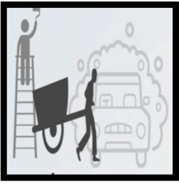  Victims are made to work long hours, often in poor conditions, and have their wages taken away. Common locations include car washes, nail bars, farm work and manual labour |  | Human trafficking  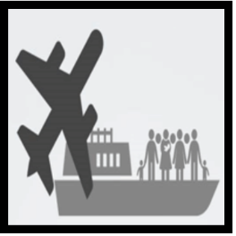  Human trafficking is the movement of people using force, fraud, coercion or deception, with the aim of exploiting them.  This can be international or within the UK |  | Criminal Exploitation  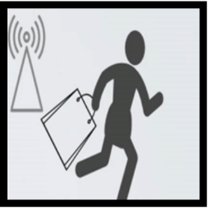  Victims are forced or coerced in to carrying out criminal activity, including begging, shoplifting or cultivating drugs and drug trafficking
Sexual Exploitation  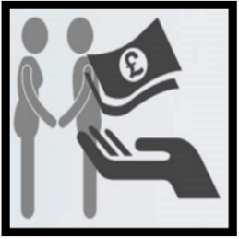  Victims are forced to work in the sex industry, sometimes in a variety of locations |  | Domestic Servitude  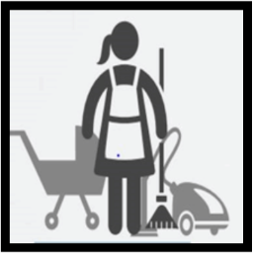  Victims are forced to carry out household tasks, with no compensation for their work. Movement is often restricted |  | - If you are concerned you’ve come across modern slavery itis important you report it if you feel safe to do so.  - In an emergency, you should always call 999. In a non-emergency, call the police helpline on 101.  - For confidential advice, contact the modern slavery helpline on 0800 0121 700
Modern slavery is often a hidden crime. Victims may be too scared to disclose what has happened to them, sometimes for fear of violence to them or their family. Some victims do not even realise that they are being exploited.
Possible signs that someone could be a victim of modern slavery include:

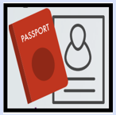  Their passport and other personal items being held by someone else, and not having access to their wages  Being unable to come and go from their own home. They may not be allowed to travel on their own and rarely interact with neighbours or co-workers |  | Working long hours; they may be dropped off and collected for work either very early or late at night, on a regular basis  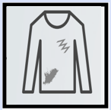  Person may appear unkempt and wear the same clothes day in day out. The clothes they wear may not be suitable for their work |  | 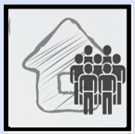  Living in shared accommodation with other workers, often in poor conditions. They may also live and work from same address  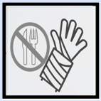  Person may be malnourished or have unexplained injuries, with no access to medical care
If you are concerned you’ve come across modern slavery itis important you report it if you feel safe to do so.
In an emergency, you should always call 999. In a non-emergency, call the police helpline on 101.
For confidential advice, contact the modern slavery helpline on 0800 0121 70

