My Early Years
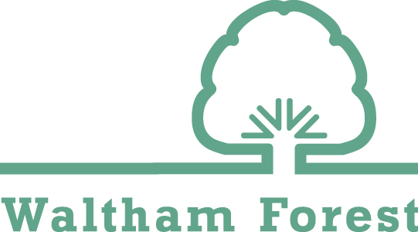
Support Plan
Name:
Date of Birth:
Gender:
Setting:
Plan Start Date:
Plan Review Date:
Plan Version No:

Me

My story and how to support me
PICTURE
interests, views, diagnosis, day to day life (regular appointments, nursery), play, health, relationships, future plans, how best to support me

 | What is working well that we want to improve? | What is not working well that we want to develop?
Communication and Language
(Communication and Interaction)
Personal, Social and Emotional
(Social, Emotional and Mental Health)
Physical
(Sensory and Physical)
Thinking
(Cognition and Learning)
My Team
Y
Our views and how to support us
Interests, Views, Areas the families need support, Times that are difficult for me or family to attend appointments, Barriers that might make it more difficult for me or family to attend appointment, preference communication method, main spoken language – communication needs in these areas.

People in my family |  |  | Activities me and my family enjoy
Name | Relationship |  | Activity | Where? | When?

Professionals supporting me and my family
Name | Role | Service | Area of Support | How are they supporting me and my family?
My Progress

When the child has is secure in the Step and EYFS stage (have been observed to be able to achieve nearly all of the items in the Step) - enter the date in the corresponding box and colour code this according to the term. Children are likely to be achieving new things in different steps at any one time, so check backwards and forwards in each area. Overall presenting age will be the lowest step age range the child has been assessed as in any area.

 |  |  |  |  | Baseline Assessment |  |  |  | Child’s First Term |  |  | Child’s Second Term |  |  |  | Child’s Third Term
Date of assessment
Chronological age at assessment in months
Overall presenting age at assessment in months
 | Assess
 | EYFS Observation Checkpoints Around 6, 12, 15, 18, 24 and 36 months |  |  |  |  |  |  |  |  |  |  |  |  |  | EYFS Observation Checkpoints Around 36 and 48 Months |  |  | EYFS Reception
 | Step 1  0-3m | Step 2  2-5m | Step 3 4-7m | Step 4  6-10m |  | Step 5  9-13m | Step 6  12-16m | Step 7  15-19m |  | Step 8  18-22m | Step 9  21-25m |  | Step 10 24-31m | Step 11 30-36m | Step 12  35-41m |  | Step 13  40-51m |  | Step 14  50-60m
Communication and Language
(Communication and Interaction)
Personal, Social and
Emotional
(Social, Emotional and Mental Health)
Physical
(Sensory and Physical)
Thinking
(Cognition and Learning)
My Action Plan

Plan | Do | Review
Outcome | Targeted intervention | Was the agreed support fully implemented? Were there any barriers? | What has gone well? Was the outcome achieved? What was the impact for the child?
Personal, Social and Emotional (Social, Emotional and Mental Health)
Communication and Language (Communication and Interaction)
Physical (Sensory and Physical)
Thinking (Cognition and Learning)
Further Details and Consent
FEEE Eligibility | 2YO FEEE 15hrs |  | 3YO FEEE 15hrs |  | 3YO FEEE 30hrs |  | Not eligible
Eligibility code
Start date at setting
Attendance hours | Mon | Tues |  | Wed | Thur | Fri |  | Weekly Total

Is the pupil Looked After by a Local Authority? | Yes/No
Child’s Address and Postcode
Parents/Carers Address and Postcode (if different from above)
Child’s First Language
Parent/Carers First Language

Is the child eligible for EYPP? | Yes | No | Date of EYPP check
Has an application been made for DLA? | Yes | No | Date of DLA application
Is the child in receipt of DLA? | Yes | No
Has DAF funding been applied for? | Yes | No

Please sign below to indicate that you:
- Have contributed to the development of this plan.
- Understand the support that will be provided through the plan.
- Consent to a copy of the plan being shared with the Local Authority
Parent/Carer Signature |  | SENCO Signature |  | Date
Parent/Carer Name |  | SENCO Name

