Families Directorate

Learning and Systems Leadership, Waltham Forest Town, Forest Road, Walthamstow,
London E17 4JF

Children/Young people  Parents  Headteachers/SENCo  Partners | Ask For:  Email: | Eva Gunkova  eva.gunkova@walthamforest.gov.uk
Children/Young people  Parents  Headteachers/SENCo  Partners | Direct line: | 020 8496 6548
Children/Young people  Parents  Headteachers/SENCo  Partners | Date: | 10 November 2020

Dear All,

EHCP (Education Health Care Plans) framework
- Annual Reviews REFRESH AND IMPLEMENTATION

The Waltham Forest partnership in collaboration agreed to refresh the Annual Review Process ensuring its compliant and consistent across the Borough.

Background
The annual Education, Health and Care Plan (EHCP) review is the statutory process of looking at the needs and provision specified in a child/young person’s EHC Plan and deciding whether these need to change. It must take place before the anniversary of the last annual review or within a year of an Education, Health and care Plan being completed.

Overview of the Pathway
In Waltham Forest there are 6 steps on the Education, Health and Care plan pathway which can be accessed by the child/young person and family. Those steps cover school support, my referral, my story (assessment), my plan, my budget and my review. Work on the annual review process comes under Step 6 of EHCP pathway- My Review.

Reasons for Review and Refresh
Concerns over the EHCP Annual Review process and inconsistencies in compliance with statutory timeframes and good quality have been raised by parents and other partners for many years. With the re-set of SEND Vision and keeping children at heart of all we do we needed to reflect on the experiences to date and learn together going forward.

Parents experiences of annual reviews as a word cloud

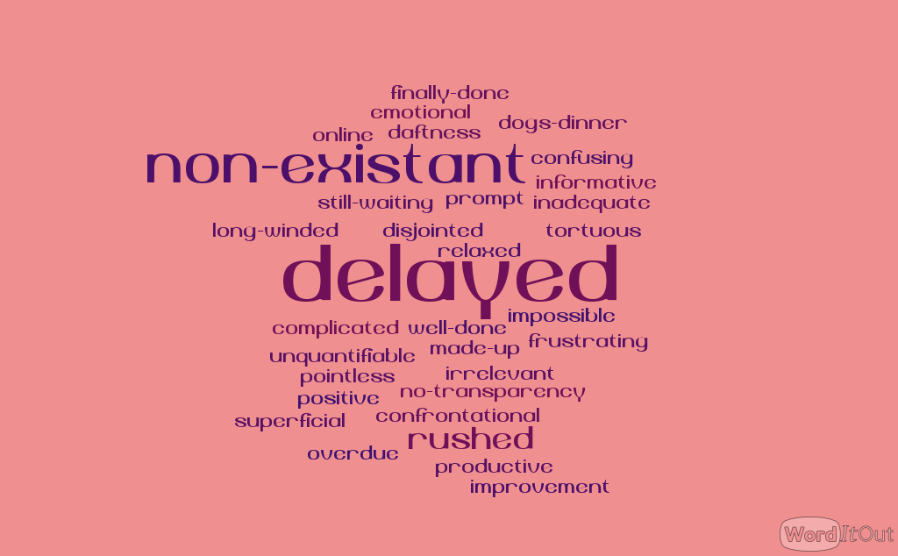

A survey by Waltham Forest Parents Forum (26th June-3rd July), highlighted some of the issues:
- Many reviews not happening annually
- Some children/young people were not involved in their review
- Some professionals don’t attend reviews, though most are invited
- Reports not always received within timescales
- Statutory timescales missed
- No notification of what will happen to the plan after the review i.e remain the same, cease,amend
- Suggested amendments to plans not sent to parents to review for 15 days
- Majority of parents don’t get an amended plan so plan doesn’t reflect the child as they currently are
- Careers advice at Year 9 onwards lacking and those who had Yr9 reviews had no Preparing for Adulthood outcomes
- Personal Budgets rarely offered and many parents don’t know what Personal Budgets can be used for

What We Did
A task and finish group was set up in July 2020-October 2020 consisting of partners from health, education, early years, the parent/ carer forum, and SENDIASS to look at the concerns raised, to develop guidance documents for everyone involved in the annual review process and to update existing documentation for children/parents and schools and settings. The task and finish group worked in co-production to develop a range of documents which will form an Annual Review Pack and are attached to this letter. Following the completion of the task and finish group, workshops have been organised for November and December to embed the process.

The Annual Review pack includes:

- Annual Review Guidance
- Easy Read Guidance for children/young people and parents
- A 7- step AR guide
- All about Me template for children/young people and parents to complete prior to an annual review
- SENCo Form for schools/settings to complete following an annual review

The pack will be reviewed annually and updated in line with any changes to statutory guidance.

Next Steps:
- Workshops organised to share, embed the refreshed Annual Review Process
- Further work on Preparing for Adulthood will commence in 2020/21 as part of a Co-production Plan

On behalf of the partnership and the co-production group I look forward to meeting you at the learning workshops and contributing to consistent, good quality annual review process for all children with EHC Plans.

Kind regards

Eva Gunkova - AD SEND Service

Danielle Roberts - SEND Officer
Vikki Monk-Meyer – DCO
Group of Parents - ParentForum
Gill Howard-Smith, Christopher Harris, Ria Mills- SENCo
Amanda Jemmeson/Assia Rehman- SENDIASS

