
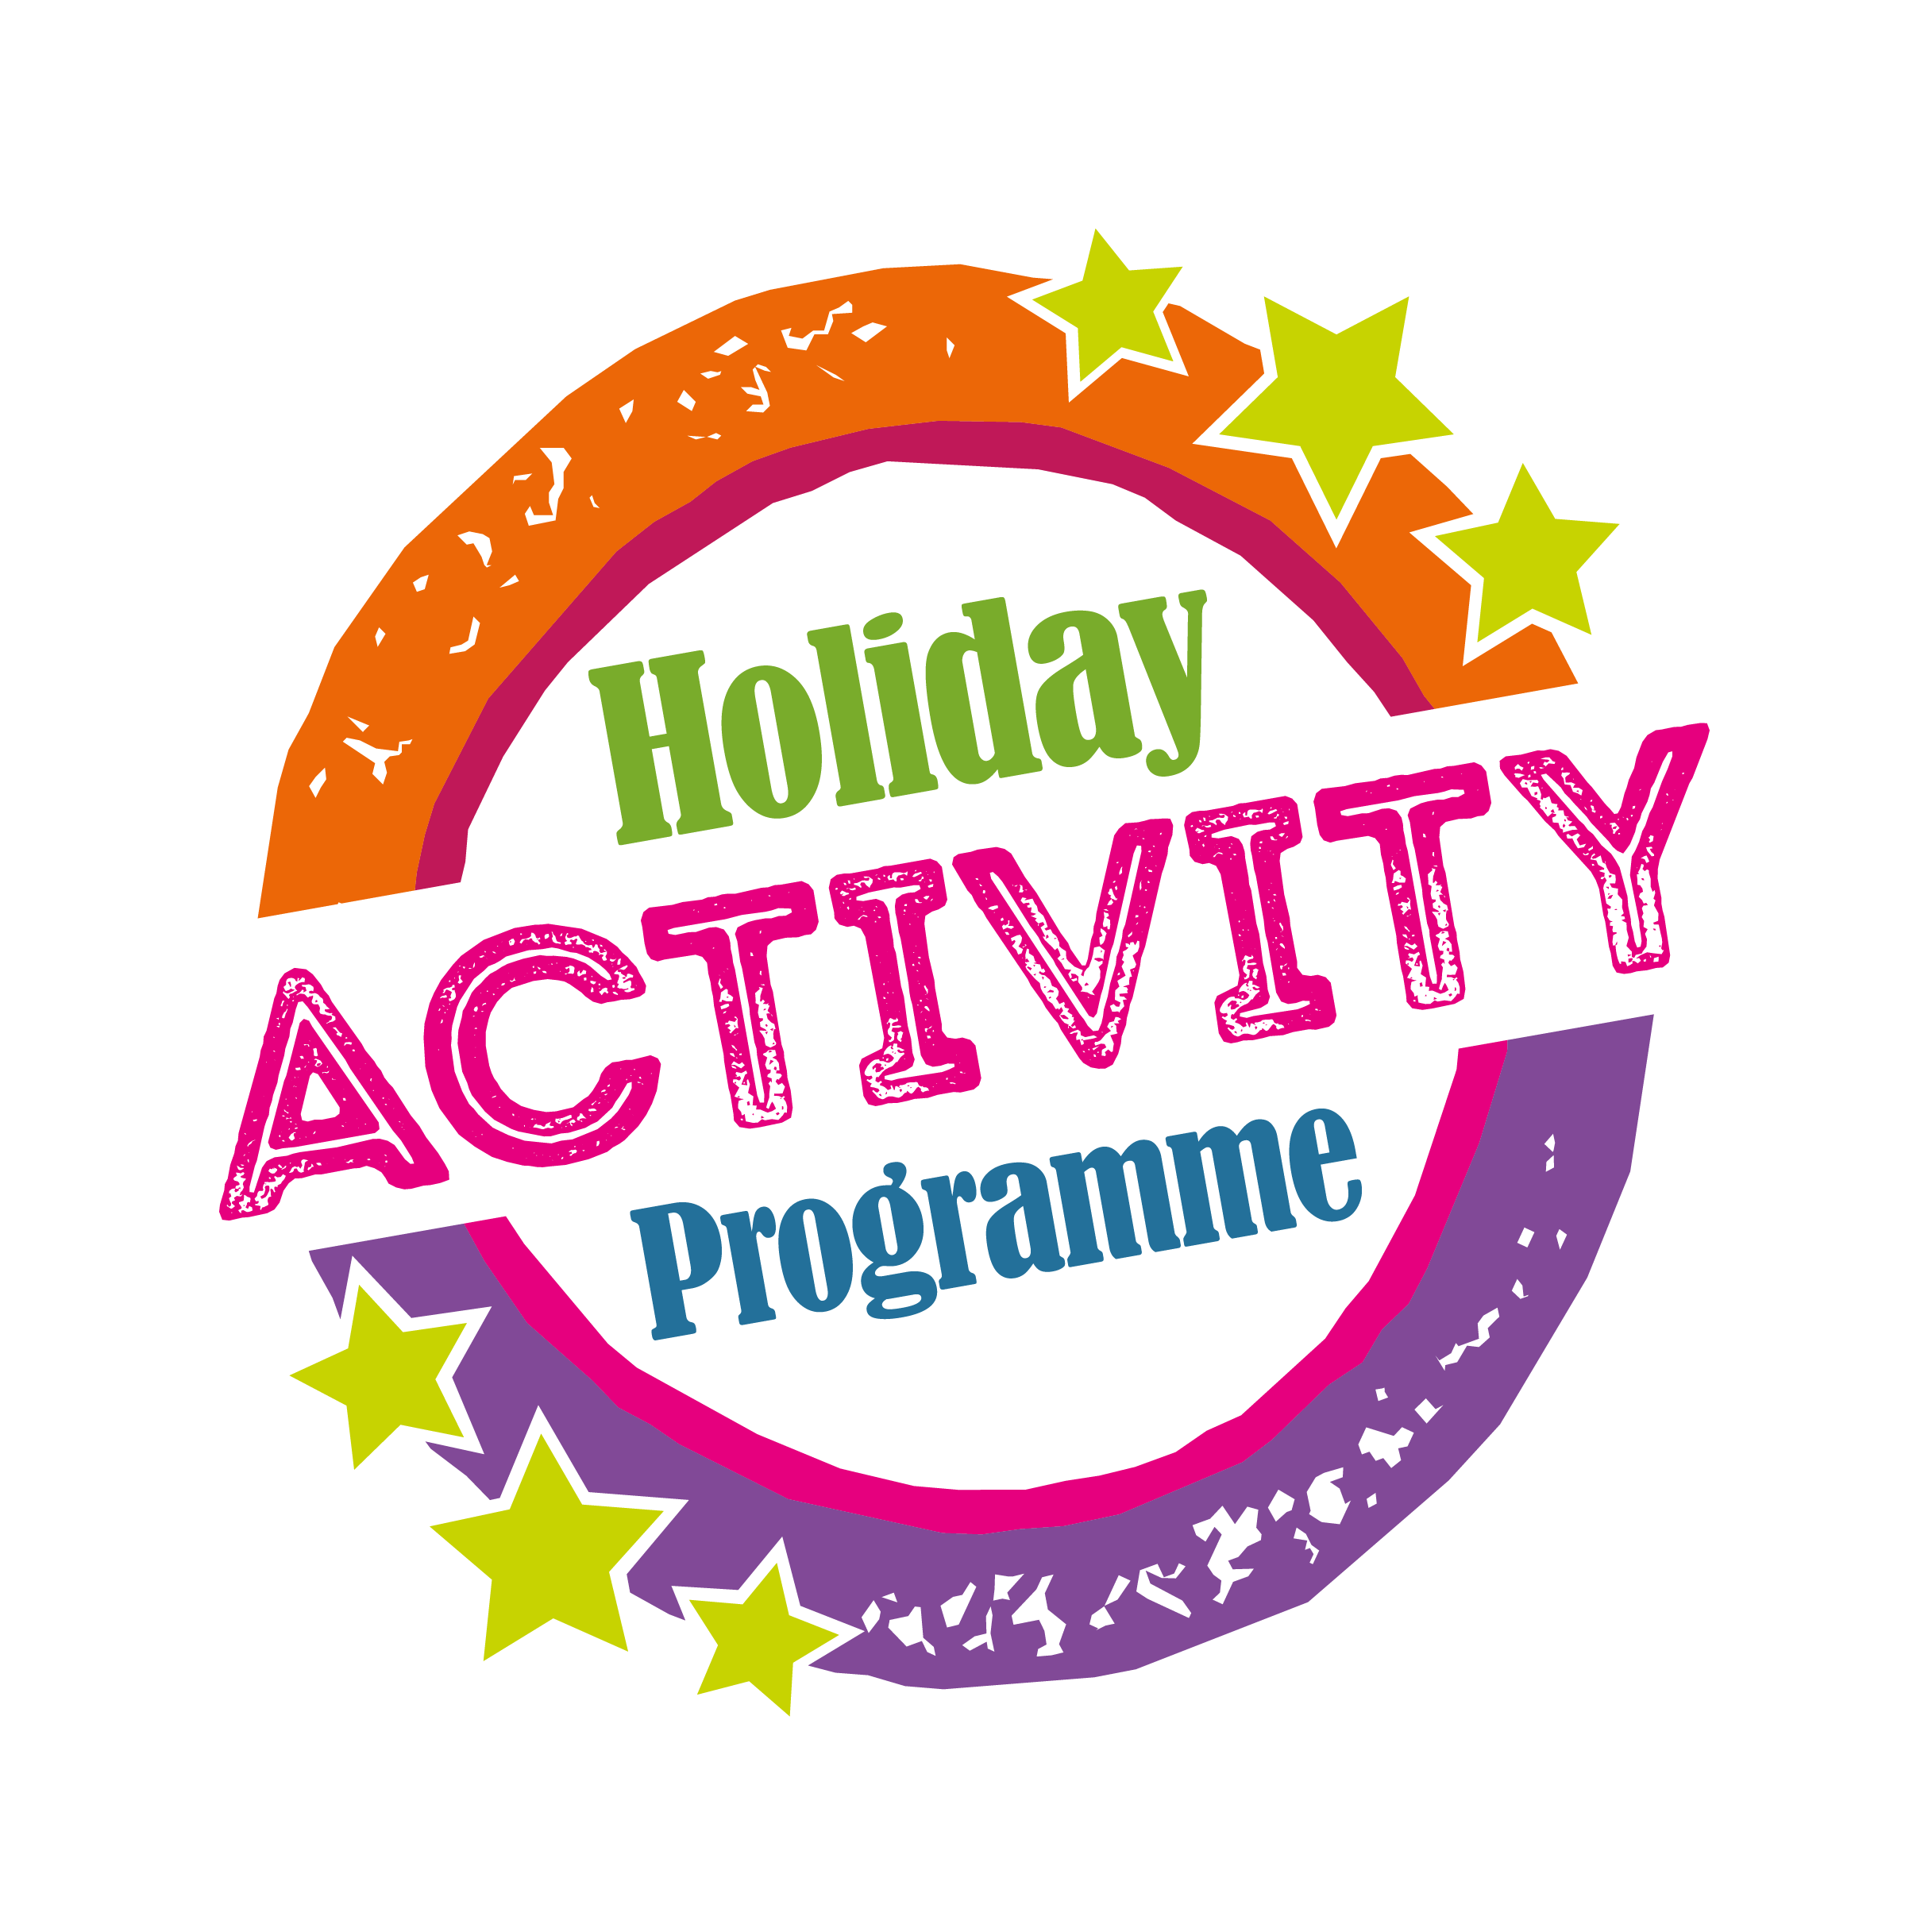
DfE Holiday Activity and Food Programme
School Grant Application – Easter 2021

- Introduction
  - The Department for Education (DfE) announced funding to enable Local Authorities across England to provide holiday activities and food during school holidays in 2021. Through this programme Waltham Forest has been awarded funding to provide 6 weeks of provision during Easter, Summer, and Christmas holidays in 2021.
  - The funding conditions of the DfE Holiday Activity Programme requires the provision of enrichment activities alongside a food offer to be made accessible for children who are in receipt of free schools meals (FSM) within the borough for up to 4 hours a day, 4 days a week during Easter, Summer and Christmas holidays.
  - The DfE does not expect all eligible children to participate and the funding provided does not enable every child in Waltham Forest eligible to FSM to be fed throughout all of the school holiday periods in 2021
  - In light of this grant funding, London Borough of Waltham Forest is offering schools the opportunity to apply for grants for activities which look to meet the following objectives:
- Provide access to enrichment activities for children in receipt of FSM during the school holidays
- Provide access to school meal for children in receipt of free school meals.

- School Based DfE Holiday Activity and Food Programme Grants 2021
Programme Outline
  - Waltham Forest will used DfE Holiday Activity and Food programme grants to focus on supporting schools, develop sustainable delivery models for enriching activity programmes and childcare provision for children aged 5-18 years old. They are open to all maintained and academy schools within Waltham Forest, including special schools and PRUs.
  - These grants will be provided to schools who are able to demonstrate via a funding application that:
- Provide a wide range of age appropriate enrichment activities which may include: Arts and crafts, drama, singing, dance, cycle coaching, entertainment and playground adventure
- Provide a safe and fun environment for children and young people
- Offer all activities free to eligible children
- Provide a free hot meal during these sessions
- Promote healthy choices and lifestyles to children and young people.
- Ensure that CYP learn, develop and engage in positive activities during the school holidays
  - Schools are able to apply within a partnership with other schools to deliver sessions. In this case one school would need to act as the lead school.
  - Places can be prioritised to children attending the host school, however schools are encouraged to deliver in partnership with other schools to meet the needs of the local area
  - Schools applying for grants towards holiday childcare programmes are expected to charge parents for attendance, whilst supporting them to access all national benefits available to them, including Tax-free childcare, Childcare vouchers, etc.
  - Sessions times are determined by school but must be run for a minimum of 4 hours a day for 4 days a week during Easter holidays

- Programme requirements:
  - Applications are required to specify:

  - a clear business plan which outlines full budget requirements for the programme including food costs
  - specify the dates of delivery they wish to apply for
  - specify the session deliver times and length of sessions
  - confirm that food will be provided and that this meets the school food standards
  - provide full details on total number of places offered by the programme and the charges to families and how families are supported to access to childcare financial support, for example registered for Tax-free childcare scheme, accepting Childcare vouchers, etc.
  - clarify the number of places that are being applied for funding for
  - outline the activities to be provided through the programme and staffing provided
  - Clarify how the provision will be inclusive for children with SEND
  - Outline how monitoring data will be collected
  - Outline how vulnerable children will be supported to ensure good attendance

  - Applications should show willingness of schools to accept referrals from Social Services where places are unfilled.
  - London Borough of Waltham Forest may award grants to a group of schools that wish to work together in partnership to provide a holiday childcare programme.

- Terms of Grant
- For the calendar year 2021 the definition eligible children are those eligible for Free School Meals
- Where more applications are received than funding available, priority will be given to places that support children who are both eligible for FSM and who are vulnerable as outlined by the DfE.
- Funding will be available to provide places for vulnerable children with a maximum grant for of £150 per week per funded place or £200 per week per funded places within special schools and PRUs.
- Funding will be provided following a completed and signed off risk assessment. Risk Assessments will be required 2 weeks before delivery.
- All marketing material must be joint branded with Waltham Forest Holiday Activity Programme Logo and School Logo (if used)

- Outcomes
Schools will be asked to demonstrate how the delivery will meet the following outcomes:
- Healthy meals: provision must provide at least one healthy meal a day and must meet the School Food Standards throughout the day.
- Enriching activities: provision must provide fun and enriching activities that provide children with opportunities to develop or consolidate skills or knowledge, to consolidate existing skills and knowledge. Clubs must also 8 provide physical activities which meet the Physical Activity Guidelines on a daily basis.
- Nutritional education: provision must improve children’s knowledge and awareness of healthy eating and offer advice and training to parents on how to source, prepare and cook nutritious and low-cost food.
- Signposting and referrals: provision must be able to provide information, signposting or referrals to other services and support that would benefit the children who attend their provision and their families.
- Policies and procedures: schools must be able to demonstrate and explain their safeguarding arrangements and have relevant and appropriate policies and procedures in place in relation to: safeguarding, health and safety, insurance, accessibility and inclusiveness.
- Role of London Borough of Waltham Forest
The London Borough of Waltham Forest will take full responsibility for commissioning, quality assurance and contract compliance of provision and will hold final accountability for all the commissioned providers.
Providers who are included in the Holiday Activity Programme commissioned arrangements:
- Will have gone through the application process and met the required standards of practice
- Will own a portfolio of evidence to share with London Borough of Waltham Forest about the effectiveness of the programmes offered
- Will be prepared to work in collaboration with London Borough of Waltham Forest within an agreed quality framework.

- Monitoring and Evaluation
  - Schools will be required to meet agreed performance indicators which will include:
- Attendance data, including school child attends, childs home postcode
- Where possible, case studies and photographs of activities.
  - Monitoring and Evaluation of this agreement will be a critical element of commissioning of this service. At least one spot check will occur to enable us to assess the effectiveness of this service.
  - Monitoring and evaluation will help us to judge whether schools are achieving their aims and objectives and making a difference
  - Monitoring will be based on the following:
  - INPUTS – staff, specialist skills and expertise, venues, resources
  - OUTPUTS – activities, services
  - OUTCOMES – service users – evidence of progress, improved health outcoming.
  - IMPACT – wider impact for families and community
London Borough of Waltham Forest may hold back payment in respect of any part of the service specification that providers have either failed to provide or provided inadequately.

