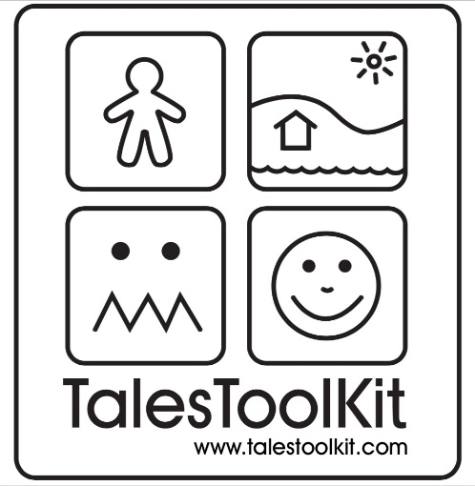

Waltham Forest Enrolment form
Please complete the enrolment form to take up the Tales Toolkit special offer of reduced membership fees and Waltham Forest’s £100 contribution.
Return the completed enrolment form to
rhys@talestoolkit.com and info@talestoolit.com

Send your Tales Toolkit invoice into EYtraining@walthamforest.gov.uk to receive £100 off your membership.

Name of Setting:

Type of Setting (School / PVI / Childminder):

(If PVI) Number of Staff:

Address:

TTK Lead Person:

Contact Email:

Contact Number:

Website:

