All About My Child
Starting school is an exciting time for you and your child and a time of change. For a positive start to school, it is beneficial for your child’s new teacher to know a little about your child before they start school to ensure the classrooms and experiences are ready to support your child’s individual needs and interests from day one.

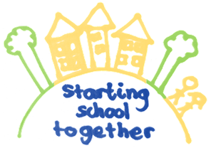

This is me  Insert a photo of your child or ask them to draw their portrait  Circle words that describe your child. You can add other words too  Funny, quiet, independent, likes routines, dreamy, adventurous, lively, curious, friendly, anxious, sociable, confident, active, kid, sensitive…. |  | My name is…  I like to be called…  My birthday is … I am …. Years old  These are the languages I speak at home…  These are my special days (e.g. cultural celebrations)  My medical needs…  I have been to a nursery or childminder: Yes / No  I have been there since…

These are the people who are important to me. Parents, carers, siblings, grandparents, aunts and uncles and family friends that are regularly involved in the day to day care. |  |  | How do I feel about starting school? Circle the words that describes how your child is feeling about starting school or add your own.  Excited, happy, brave, worried, scared,  Who do I know going to my new school?  My friends are ….
Things I like:  My favourite stories, rhymes and songs:  My favourite toys, games and activities:  My favourite places to visit before lockdown:  What I like to do during lockdown: |  |  |  | Things I don’t like  Things that can upset, frighten or worry me  How you can comfort or calm me  include different ways that you can be soothed e.g. cuddles, singing, distraction

Regular activities I joined in with before lockdown:  Does your child attend for example dance class, swimming, football?  My current interests are  What does your child like doing, watching on the tv |  | At home I am practising:  Go to the toilet by myself  Wash my hands  Put on my coat, shoes and clothes by myself  Pouring my own drink  Drinking from a cup
How does your child separate from you? Are they happy to leave you? Do they get upset when they leave you or happy to leave you after a while?

What experience does your child have of playing with other children? For example, has your child attending nursery or childminders

Is there anything you would like us to know or are concerned about?

For ideas on supporting your child get ready and excited about starting look out for the starting
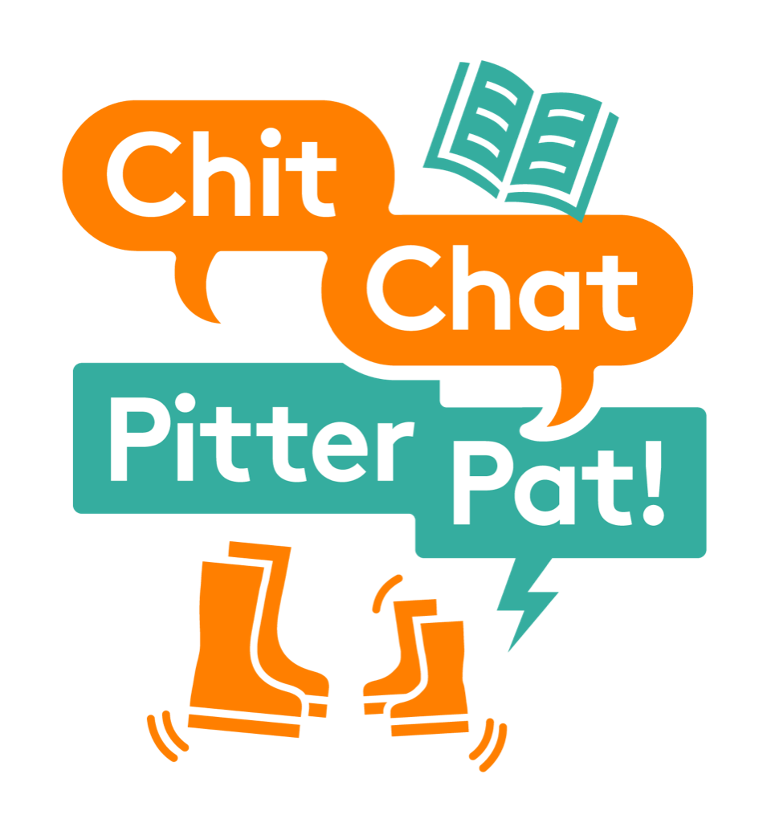
school together challenges on https://www.facebook.com/chitchatpitterpatLBWF/
https://www.instagram.com/chit_chat_pitter_pat/

