
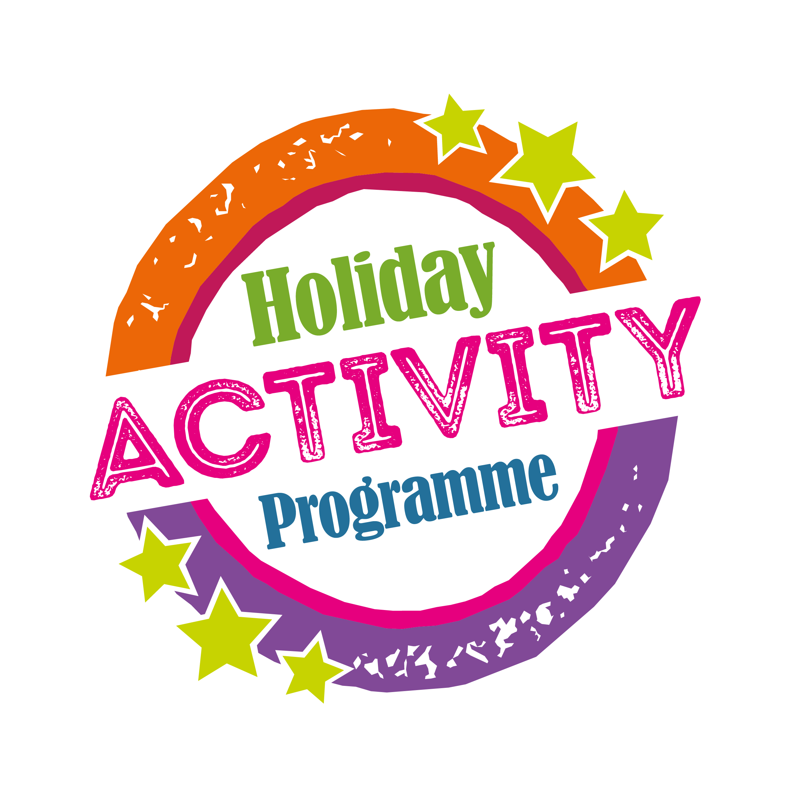
London Borough of Waltham Forest Holiday Activity Programme – School-based Childcare Grants
Grant Application
- Introduction
Waltham Forest’s Holiday Activities Programme is part of the Leader’s Pledge to provide a universal Easter and Summer holiday enrichment programme of positive opportunities open to all children and young people (CYP) living or being educated in the borough, aged between 5-18 years old, and up to 25 years for young people with a disability.
There are three parts to the programme:

- 2.5 hr Family sessions aimed at 5-11 year olds
Previous delivery has shown that this aspect is extremely popular with local families with young children and will continue to be delivered across a number of locations within the borough.
- A positive activity programme aimed at 11-18 year olds.
Following a successful pilot year in 2016 we be continuing to offer an exciting and innovative range of extended activities and courses for young people to learn new skills and have new experiences. This element is intended to extend and diversify the range of activities on offer in order to increase participation of young people.
- School-based childcare Grants
Grants are provided for schools to provide affordable childcare for working families and targeted places for vulnerable children during school holidays.

- Background
Waltham Forest’s Holiday Activity Programme has been running throughout the Easter and Summer Holiday since 2010 and aims to offer a variety of exciting and interesting activities including, sports, creative and performing arts, and environmental activities.
The Council is committed to a commissioning process that promotes local growth and sustainability and acknowledges that a strong collaborative and partnership approach in developing the programme can lead to a diverse and quality provision.
External providers are invited to provide activities across London Borough of Waltham Forest. London Borough of Waltham Forest will ensure that during the commissioning process there is an appropriate geographical spread of activities for children and young people across the borough.
- The Aims of the Holiday Activity Programme are:
- To provide a universal offer of a wide range of activities, multi-sports, performing and creative arts activities and environmental activities for children aged 5-19 (and up to 25 for CYP with a disability) who live or attend school in London Borough of Waltham Forest.
- To provide all activities free to children and young people.
- To support children from vulnerable families and those on low incomes to access positive and enriching activities
- To support children from vulnerable families and those on low incomes to access affordable childcare.
- To provide a safe and fun environment for children and young people during the Easter and Summer holiday periods
- To promote healthy choices and lifestyles to children and young people.
- To ensure that CYP learn, develop and engage in positive activities during the school holidays
- To provide training opportunities and work experience to young people in London Borough of Waltham Forest for example young sport coaches support with sessions.
- To encourage families to access and enjoy local opportunities and provision
- To provide employment opportunities for local people
- To support the sustainability of local businesses, clubs and the voluntary sector
- To encourage London Living wage for payment of all staff and any third party commissioned groups.
- Role of London Borough of Waltham Forest
The London Borough of Waltham Forest will take full responsibility for commissioning, quality assurance and contract compliance of provision and will hold final accountability for all the commissioned Easter and Summer providers.
Providers who are included in the Holiday Activity Programme commissioned arrangements:
- Will have gone through the application process and met the required standards of practice
- Will own a portfolio of evidence to share with London Borough of Waltham Forest about the effectiveness of the programmes offered
- Will be prepared to work in collaboration with London Borough of Waltham Forest within an agreed quality framework.
- School-Based Childcare Grants
  - Programme Outline
- Waltham Forest’s School-based childcare programme, will focus on supporting schools develop sustainable delivery models for holiday childcare and supporting vulnerable children.
- Schools applying for grants towards their holiday programme are expected to charge parents for attendance, whilst supporting them to access all national benefits available to them, including Tax-free childcare, Childcare vouchers, etc.
- The grants provided will not cover full delivery costs of the schools programme, but targeted funding for vulnerable children is available.
- School childcare programmes must be delivered during school holidays (Easter and Summer) for a minimum of one week and a maximum of six weeks.
- Sessions times will be determined by the school but must be run as a maximum full day of 8am – 6pm or a minimum of 10am – 3pm.
- Waltham Forest School-based Childcare Grant must be fully inclusive.
- Places can be prioritised to children attending the host school, however schools should also be willing to offer any unfilled places to children within the borough.
- Sessions must be play based and should offer a range of positive age appropriate activities, which may include: Arts and crafts, drama, singing, dance, cycle coaching, children’s entertainment and playground adventure.
  - Programme requirements:
- Tenders are required to specify the minimum and maximum of weeks they wish to apply for during the Easter and Summer Holiday’s.
- Tenders are required to specify the session length.
- All programme applications to include full details on the maximum and minimum number of Children and young people the session can hold.
- Tenders are required to include the school extended services charging, admissions and Inclusion policies.
- Tenders are required to outline how the school will market the programme within the school and to families within the local area.
- Tenders are required to support low income families to gain access to childcare financial support, for example registered for Tax-free childcare scheme, accepting Childcare vouchers, etc.
- Tenders are required to specify the number of places that they are allocating for targeted vulnerable children.
- Tenders should show willingness of schools to accept referrals from Social Services where places are unfilled.
- London Borough of Waltham Forest may award grants to a group of schools that wish to work together in partnership to provide a holiday childcare programme.
- Applications must include a clear business plan which outlines full budget requirements for the programme and detail the future sustainability of the programme.
- All marketing material must be joint branded with Waltham Forest Holiday Activity Programme Logo and School Logo (if used)
  - Terms of Grant
- Funding will be provided to support schools develop a sustainable childcare programme.
- Funding will be available to provide places for vulnerable children with a maximum grant for of £150 per week per funded place or £200 per week per funded places within special schools.
- Please see attached document for the definition for this programme of Vulnerable Children.
  - Outcomes
Schools will be asked to demonstrate how the delivery will contribute to the following outcomes:
  - Number of affordable childcare places delivered
  - Number of places delivered for vulnerable children
  - Provide a comprehensive range of positive activities for 5-11 year olds
  - Where possible, offer an inclusive range of activities to all children and young people.
  - The opportunity for children and young people to try new activities and learn new skills.
  - To provide children and young people with local pathways to continue to develop their interests and skills.
  - Where possible, to offer the programme to children within the local community who do not attend the school?
- Monitoring and Evaluation
- Schools will be required to meet agreed performance indicators which will include:
  - Full project report at the end of the programme delivery
  - Attendance data, including school child attends, childs home postcode
  - Where possible, case studies and photographs of activities.
- Monitoring and Evaluation of this agreement will be a critical element of commissioning of this service. At least one spot check will occur to enable us to assess the effectiveness of this service.
- Monitoring and evaluation will help us to judge whether schools are achieving their aims and objectives and making a difference
- Monitoring will be based on the following:
  - INPUTS – staff, specialist skills and expertise , venues, resources
  - OUTPUTS – activities, services
  - OUTCOMES – service users – evidence of progress, improved health outcoming.
  - IMPACT – wider impact for families and community
London Borough of Waltham Forest may hold back payment in respect of any part of the service specification that providers have either failed to provide or provided inadequately.

