Name: |  | Date of Birth: |  | Age in Months:
I joined the setting on: | My Key Person is: |  |  | Languages I use at home:
Have I had my 24 Month Health Review with the Health Visitor? YES/NO
If yes, where any concerns raised about my hearing, toileting, speech, sleeping, dental or diet?

My family have notices that I am interested in … |  |  | My key Person has noticed I am interested in…
My family would be happy if I…

My characteristics of effective learning. I like to learn by… |  |  | Communication and Language: Look at what I can do!  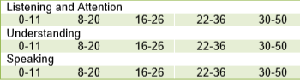
Personal Social and emotional development: Look at what I can do!  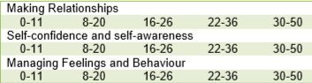 |  |  | About my Physical Development: Look at what I can do!  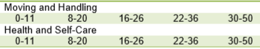

My next steps are:

At nursery we could:

At home we could:

Is there any support that I can get from anyone else?

My parents/carers comment:

Signed Parent and/or Carer ________________________ Key Person _______________________________

Manager _____________________ Date___________________________

