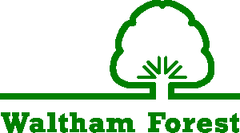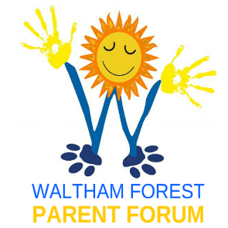

ALL ABOUT ME
My needs: (What are my diagnosis?)

Communication:

How do I prefer people to communicate with me (e.g. using signs, visual prompts, speak clearly etc)

My views:

My family’s views:

My views:

What would I like people to know about me?

What am I good at?

What are my hobbies and interests?

My story – who do I live with, where do I go to school?

My views:

My family’s views

Good Support
What I want people to know and understand about the type of support I need
How I don’t like to be helped/supported

Aspirations, Interests and Goals

My views:

My family’s views:

My Hopes for the Future as I grow older

My views:

My family’s views:

Written by _________________________________________________

